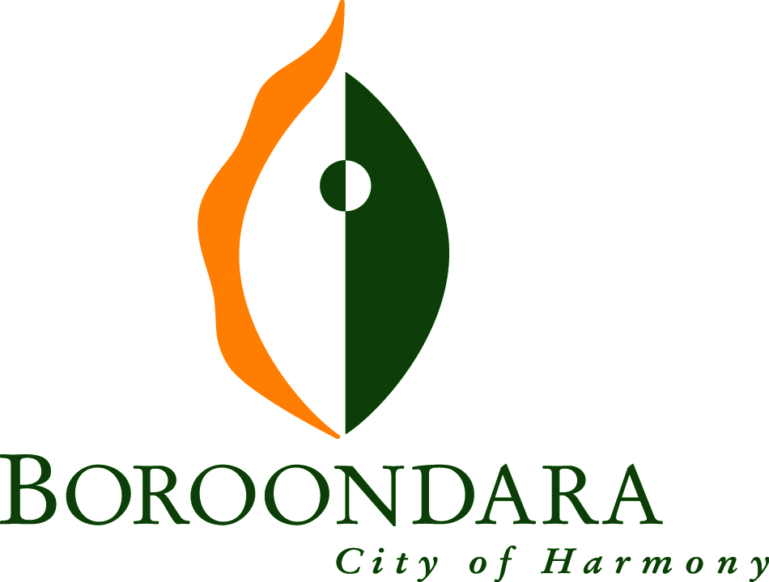
Boroondara Community Plan
2017-27

Responsible Directorate: Community Development
Authorised by: Council
Date of adoption: 11 December 2017
Review date: 30 June 2021

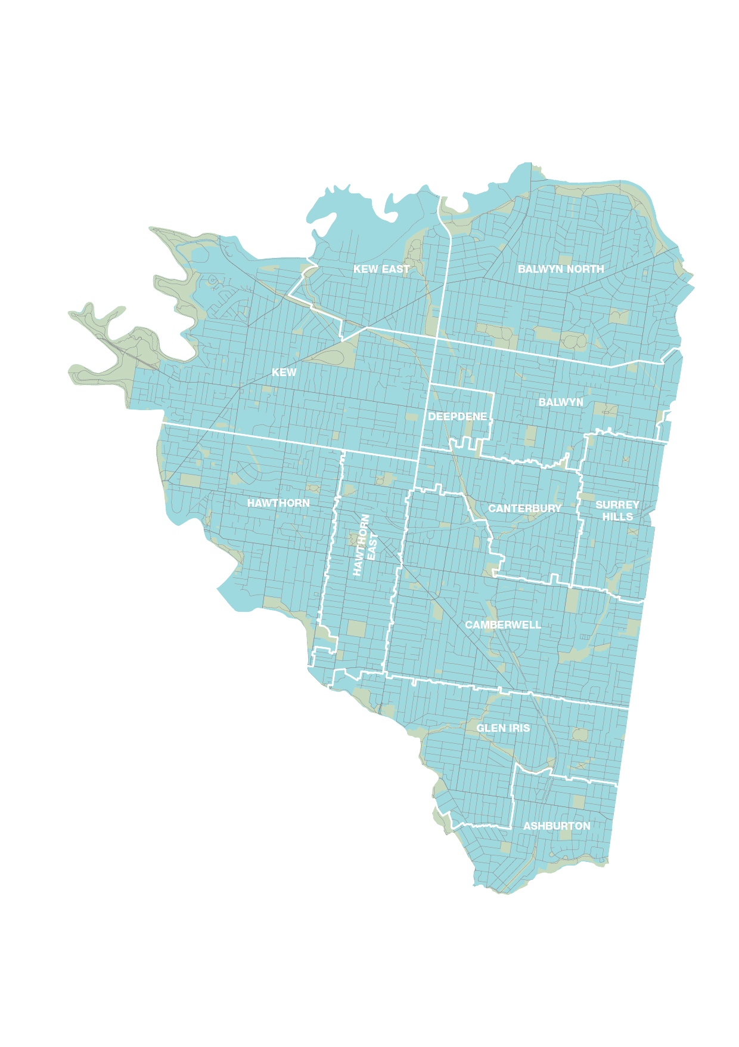

The Vision for Boroondara’s Future

A vibrant and inclusive city, meeting the needs and aspirations of its community

Table of contents
The Vision for Boroondara’s Future 3
Message from the Councillors 6
Creating the Boroondara Community Plan 10
Preamble 14
Our Wellbeing Commitment 15
Priority Themes 16
Priority Theme 1: Your Community, Services and Facilities 17
Priority Theme 2: Your Parks and Green Spaces 18
Priority Theme 3: The Environment 19
Priority Theme 4: Neighborhood Character and Heritage 20
Priority Theme 5: Getting Around Boroondara 21
Priority Theme 6: Your Local Shops and Businesses 22
Priority Theme 7: Civic Leadership and Governance 23
Our Health Priorities 24
Implementation and Monitoring 27
Implementation 27
Evaluating and Refreshing the Plan 28
Partnerships 31
Keeping in touch with the community 31
Acknowledgements 31
Appendix 1 32

Message from the Councillors
It is with great pride and pleasure that we, the elected representatives of the City of Boroondara, present your community plan for Boroondara for the next 10 years.

Boroondara is a remarkable place to live, work and recreate, and it provides an exceptional quality of life for our residents.

According to Council’s forecast, our City will grow by 15,044 people between 2017 and 2027. We know the needs of our community will change as we adapt to advances in technology, respond to an ageing community, changes to our environment and demand on our local resources and services.

In order to plan for the next 10 years of our City’s future, we needed to know what was important to you.

Between November 2016 and April 2017, we undertook the largest program of community consultation that we have ever done before. We wanted to spark a conversation about the future and engage as many people in as many different ways as we could.

The response was wonderful with 11,845 responses contributing to the conversation.

You told us that you value our leafy streets, safe and friendly neighbourhoods, the parks and gardens and the many opportunities to enjoy leisure, recreation, cultural and social activities and events. You also told us that the services and facilities provided by Council play a critical role in providing support for the community across all age groups, and contribute to good health and a sense of connection.

Equally, there was a strong message that you are aware of changing times in Boroondara, and globally, which create challenges for the community and the place we live. These included the need to manage potential conflicts in use of open space for passive and active recreation, and the loss of a sense of community due to the effects of higher density development.

We have sought to understand your needs and aspirations, and reflected these in a plan for the future of our vibrant City.

The consultation revealed seven priority themes, which form the basis of the Boroondara Community Plan. The Plan will provide a roadmap for us to work alongside our partners and our community to achieve this vision.

We are excited about the future and committed to keeping the community conversation which brought the Plan to life going by involving you in the implementation and review process.

We are listening to you, we have heard you and we will work together to deliver on your priorities. The Plan’s vision, strategic objectives and strategies provide a response to the community’s priorities over the next 10 years.

On behalf of Council, we would like to thank our community for your passion and contribution in developing the Boroondara Community Plan.

City of Boroondara Councillors
2017

Boroondara
by the numbers

Who we are
177,361
people live in Boroondara.
15,049
more residents will call Boroondara home over the next 10 years to 2027 with almost a quarter of these aged over 60 years.

316
residents identify as Aboriginal and/or Torres Strait Islanders.

6,406
residents need help in their day-to-day lives due to a disability and two-thirds of these are aged over 70 years.

45,568
residents speak another language at home. Mandarin (13,700 speakers), Cantonese (4945), and Greek (4760) are the three most common languages spoken after English.

51,635
residents were born overseas. China (11,063), United Kingdom (5849), and India (4050) are the most common overseas countries of birth.

6,784
residents do not speak English well or did not speak it at all.
43.2%
of residents over 15 years have a Bachelor degree or higher.

35,999
residents reported doing some form of voluntary work in 2016.

57%
of the working population are employed as managers and professionals.

How we live¹
62,794
households live in Boroondara.

7313
more households are expected to live in Boroondara between 2017 and 2027.

22,020
households are couples with children, which is the most common household type.

17%
of households have a weekly income of less than $740, the lowest income quartile for Victoria.

43%
of households have a weekly income of over $2395, the highest income quartile for Victoria.

757
households live in state housing authority or community organisation provided dwellings.
55%
of dwellings are separate houses.

380
people identified as homeless in 2011.

$406
is the median weekly rent, which is higher than the median for greater Melbourne ($350).

$2,500
is the median monthly mortgage repayment. The median for greater Melbourne is $1,800.

Our Economy
8,862
businesses in Boroondara employ people.

15,981
businesses in Boroondara do not employ people (for example, sole proprietorships).

53
shopping centres and strips are in Boroondara.

1,354
registered retail businesses in Boroondara.

387
more jobs in Boroondara in 2015-16 than in 2010-11.

120
fewer full-time equivalent jobs between 2010-11 and 2015-16.

What people from different life stages told us was important to them in Boroondara.
“Having services which support family life - libraries, events, other support services - a safe community to live in.” 25 to 39 years | “I’ve lived here all my life and it’s been wonderful. The preservation of nature and planting of trees and the freedom of existence is important to all humanity.” 80 years and over
“The most important thing to me is having parks which everyone can enjoy.” Under 15 years | “Educational activities that are community-based and not just at school.” 15 to 24 years
“I love the community feel of our streets and we need well-planned development to retain them.” 25 to 39 years | “A vibrant and interesting suburb, alive with events.” 65 to 79 years
“What is important to me is making everyone feel safe.” Under 15 years | “Opportunities to meet other members of the community.” 25 to 39 years
“Have more seats to rest on to make it easier for older people and they could rest or wait for other people” Under 15 years | “Encouragement of small businesses.”  65 to 79 years
“It’s important to be able to walk or ride my bike to the local shops.” 25 to 39 years | “I like the local shops because they have places to eat with my family” Under 15 years
“Parks, grasslands and somewhere to walk that is green.” 15 to 24 years | “Safe places for all members of the community, as well as activities at libraries, markets and community centres.” 65 to 79 years
“Social justice, equitable services, and affordable housing.” 25 to 39 years | “A sustainable supply of services that does not involve increasing rates at will, but rather meets the needs of the larger community.”  40 to 64 years
“Reducing traffic in residential areas, reducing speed limits.” 25 to 39 years | “I value environmental awareness and simple acts such as putting in more drink bubblers.”  15 to 24 years
“Clear and recognisable leadership from Council and groups supported by Council.”  40 to 64 years | “More facilities and assistance for seniors.”  65 to 79 years
“That we keep our waterways clean and properly dispose of waste.” 65 to 79 years | “Nature is caring and grows food for us. We can care for nature by leaving it nice.” Under 15 years
“Thriving commercial areas with a wide range of shops and served by good public transport.” 65 to 79 years | “Good library service and local shopping strips that foster community spirit.” 40 to 64 years
“More bike paths which are safe and better public transport will mean fewer cars on the road.” 40 to 64 years | “I like the libraries because they aren’t only for children or aren’t only for adults. They are places for everyone.” Under 15 years
“Shopping at local shops.”  80 years and over | “I would make sure every single person in the neighbourhood has a home. We would all know each other and have parties.” Under 15 years
“A leafy environment and warm, welcoming people. Open spaces, sympathetic architecture and sensitive community leadership.” 65 to 79 years | “A leadership that is committed to making Boroondara a place where all can live with equity in a safe, pleasant environment.” 65 to 79 years

Creating the Boroondara Community Plan

In 2016, we commenced the development of a new Council vision, to reflect our community’s values, aspirations and priorities for the next 10 years. It was also decided for the first time to integrate the Municipal Public Health and Wellbeing Plan into the community plan, and make the community plan our key strategic document. This was to ensure the health and wellbeing of the community is at the centre of everything we do, and every part of our operations are involved in supporting the directions articulated in the community plan.
As a first and fundamental step in the development of the community plan, Boroondara’s councillors wanted to hear directly from the community. Between November 2016 and April 2017, 11,845 responses were received from people who live, work, study or recreate in Boroondara, the largest consultation activity ever conducted by the City of Boroondara. The community was passionate and enthusiastic in telling us what is important to them.
The consultation approach was two-stage: first, we heard about the broad range of issues that are important to our community, next, we learned how our community prioritises the aspects of life in Boroondara they identified as important.
Stage One - the ideas phase
Between November 2016 and February 2017, we received 7,182 responses from the Boroondara community to the question “What’s important to you in Boroondara?” This open-ended question was designed to ensure that we had the opportunity to hear about all issues the community wanted to nominate.
Ideas and opinions of the community were submitted to Council online, over the telephone, in workshops, and via postcards distributed by our staff at community events and throughout Boroondara’s shopping strips, public transport stops and community facilities. Targeted surveying methods were used to ensure that the sample of respondents was as representative as possible of the broader Boroondara community on key demographic factors.
Every response was assigned to a topic category, or multiple topic categories. The most frequently reported topics were grouped into 33 subthemes. The subthemes were in turn grouped into seven priority themes.
The 7,182 responses received during Stage One gave us a substantial body of evidence about what our community would like us to address.
Stage Two - prioritisation
In the second stage of consultation, 4,663 responses were received from members of our community, who either chose their “top three” from the seven priority themes identified in Stage One, or allocated a hypothetical budget among the priority themes.
This process was designed to inform us about whether each of the identified priority themes maintained a level of importance to the community, and which were the most important, in the context of limited resources. This reflects the constraints within which we operate.
The community prioritised the themes via an online survey and a telephone survey, in person during workshops and at community events across Boroondara. The ranking and budget allocation results were statistically adjusted to ensure the voice of any demographic groups who were underrepresented in the sample were assigned a fair weighting. This process was consistent with appropriate research methodologies.
Overall, many people said all seven themes were worthy of attention, and therefore it was difficult to prioritise one theme over another. This outcome confirmed that every theme identified during Stage One was important, even in the context of limited resources.
Details of the consultation findings are available on Council’s website at <insert link here>.
Stage Three - identification of health and wellbeing priorities
To meet the legislative requirements of a Municipal Public Health and Wellbeing Plan, we examined data indicative of the health and wellbeing status of the Boroondara community. This was guided by the priority themes identified in the community consultation data, and the health and wellbeing priorities described in the Victorian Public Health and Wellbeing Plan 2015-19.
During this stage, we also developed a wellbeing commitment with local health agency partners and the Boroondara Public Health and Wellbeing Plan Advisory Committee. The wellbeing commitment highlights our dedication to improved community wellbeing through the Boroondara Community Plan addressing the legislative requirements of the Municipal Public Health and Wellbeing Plan.
Stage Four - Community plan development
Through the consultation process, we heard what our community values most about Boroondara, as well as their concerns, hopes and aspirations for the future. We used this feedback to inform the development of the community vision, and the strategic objectives and the strategies related to the seven priority themes.

Outlined below is further information about how we engaged with our community and who we heard from.

This is how we engaged
our community
18
postcard reply boxes were distributed around the City.
67
partner organisations helped us connect with community members.
340
non-Council locations were used to reach community members.

We spoke to community members at
17
community festivals and events.
13
shopping strips, cinemas and cafes.
10
library events, groups and storytimes.

11
neighbourhood houses and men’s sheds.
6
leisure centres and sports clubs.
9
public transport stops and stations.

This is how we heard from our community about their priorities

6133
people responded online.
2801
people responded via telephone surveys.
1964
people completed our community plan postcards, 52 of which were submitted in a language other than English.
490
people provided their ideas at four pop-up Council events.
169
people participated in three Boroondara conversations workshops to drill deeper into the priority themes.
92
people took part in a workshop on the wellbeing and inclusion of culturally and linguistically diverse communities in Boroondara.
177
students from Boroondara primary and secondary schools participated in workshops.
19
early years services participated in activities to share the voices of our youngest residents.

Responses were received from the following age groups
549
respondents were under 15 years.
829
respondents were aged between 15 and 24.
1862
respondents were aged between 25 and 39.
5157
respondents were aged between 40 and 79.
2427
respondents were aged between 65 and 79.
465
respondents were aged 80 or over.
Gender
6614
respondents were females.
4791
respondents were males.
Cultural and Linguistic Diversity
1318
respondents were born in a country where English is not a main language.

People from right across Boroondara responded
380
respondents lived in Kew East.
1503
respondents lived in Kew.
815
respondents lived in Balwyn.
1058
respondents lived in Balwyn North.
1469
respondents lived in Hawthorn.

806
respondents lived in Hawthorn East.
1534
respondents lived in Camberwell.

1101
respondents lived in Glen Iris.

570
respondents lived in Surrey Hills.
149
respondents lived in Deepdene.
488
respondents lived in Canterbury.

595
respondents lived in Ashburton.
536
respondents lived outside Boroondara.

Preamble
A vibrant and inclusive city, meeting the needs and aspirations of its community

The Boroondara Community Plan 2017-27 (BCP) sets out the 10-year vision for our future based on the values, aspirations and priorities the Boroondara community told us were important to them. It will build on what makes Boroondara a remarkable place to live now, and will form the foundation for us to work alongside our community and partners to achieve our vision together. As our key strategic document, it will also guide our decision making, and will directly inform the Council Plan, budget processes, and Council strategies, plans, policies and actions.
The BCP is structured around the following seven priority themes that the Boroondara community told us we should focus on over the next 10 years:
- Your Community, Services and Facilities
- Your Parks and Green Spaces
- The Environment
- Neighbourhood Character and Heritage
- Getting Around Boroondara
- Your Local Shops and Businesses
- Civic Leadership and Governance
Under each priority theme is a section noting what the community told us they value about it, what we will do in response, and how we will do it.
The BCP also identifies the health priorities that we will focus on in partnership with local agencies, and responds to the requirements of the Victorian Public Health and Wellbeing Act 2008 to have regard to the prevention of family violence, and the requirements of the Climate Change Act 2017 to respond to climate change (see Appendix 1).
To ensure we are held accountable for achieving our vision over the next 10 years, a set of strategic indicators have been developed. These will help us, our community and partners keep track of our progress and measure our success.

Our Wellbeing Commitment
​
Our health and wellbeing is influenced by much more than our individual choices. Good physical, mental and social health starts in our community, through opportunities to connect, participate and access what we need in order to make healthy choices.
Through the BCP, we are committed to striving to enhance wellbeing for people who live, work, study or recreate in the municipality as an outcome of everything we do. We will focus on providing a high quality of liveability through our planning, services, places and spaces to enable all members of the community to make healthy choices. We will prioritise action focusing on improving health in order to achieve the community’s vision for Boroondara’s future.
Our commitment to wellbeing is guided by the Victorian Charter of Human Rights and Responsibilities Act 2006, which recognises all people have equal rights to all Council services and facilities and the key role the community plays in decision-making. This commitment implies a focus on equity - fair and even access to resources – so community members of all ages, genders, backgrounds, locations and abilities have the same opportunities to achieve good health and wellbeing.
We will work together with our community and local organisations to make good health and wellbeing a reality for all by focusing on the seven priority themes the community told us are important. ​

Priority Themes
During extensive consultation, our community identified seven priority themes that we should address, which are shown in the diagram below. The six central priority themes in the diagram are focused on improving liveability throughout the City, and each represents a core component of daily life. The encircling priority theme represents our commitment to sound ethical and consultative leadership across everything we do. The seven themes together are the foundation for a healthy, happy community, achieving the vision for Boroondara.

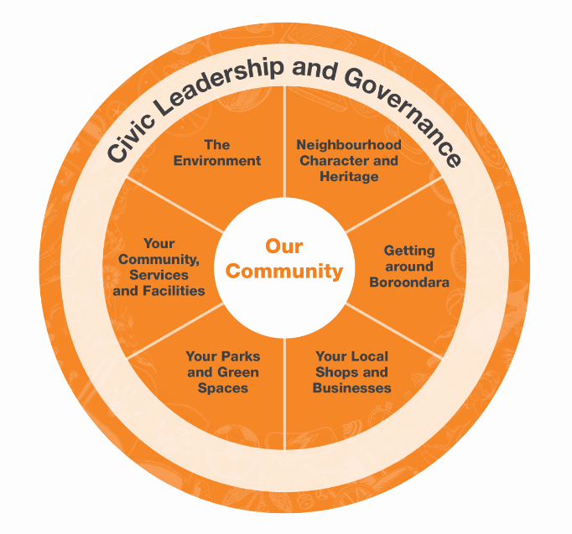

The following pages outline what the community told us about each priority theme, and the supporting strategic objective and strategies. The strategic objectives address the seven priority themes, and describe the outcomes we are seeking to achieve. The strategies describe our area of focus directed at achieving the strategic objectives. The strategies will be implemented through actions in our policies, plans, strategies, projects and budget over the next 10 years. Each strategic objective will be measured by a set of strategic indictors to monitor our progress and the influence the BCP has on the health and wellbeing of the community.

Priority Theme 1: Your Community, Services and Facilities

Our community said:

We value well-maintained public places and community events where people of all ages and backgrounds can interact, learn, and be active. We also value safety, respect and ensuring services are available to support those who may need them, including young families, older adults and vulnerable members of the community. We value these things because they contribute to good health, a sense of community connection, and harmony across life-stages.

Strategic Objective 1: Community Services and Facilities are high quality, inclusive and meet a variety of needs now and into the future.

Our strategies for how we will achieve this:

Strategy 1.1 Plan, maintain and renew multipurpose facilities and sports precincts to meet broad, intergenerational needs of the community now and into the future.
Strategy 1.2 Develop a multi-channel wellbeing information service that provides localised and individualised responses to support increased access to available services and facilities.
Strategy 1.3 Deliver, facilitate and advocate for services and programs that promote health, wellbeing, safety and a sense of community.
Strategy 1.4 Provide, facilitate and advocate for life-long learning opportunities for people of all ages.
Strategy 1.5 Provide, facilitate and advocate for opportunities to increase connections within the community, with a focus on local neighbourhoods.
Strategy 1.6 Create and maintain public areas, facilities, amenities, footpaths and spaces that are inviting, clean and appropriately lit to increase social connection and improve perceptions of safety.
Strategy 1.7 Support the community’s capacity to create and maintain safe neighbourhoods, in partnership with relevant State and Federal Government services, community groups and traders.
Strategy 1.8 Facilitate and produce diverse Arts and Cultural programs to provide entertainment and increase participation in community life for residents and tourists.
Strategy 1.9 Facilitate and advocate for opportunities to maximise older people’s quality of life and engagement in the community through the provision of programs, volunteering and community sharing projects.
Strategy 1.10 Develop a strategic response to improving the safety of public places, Council’s facilities and events and take action as required to help protect community participation.

Priority Theme 2: Your Parks and Green Spaces

Our community said:

We value Boroondara’s parks, gardens and green spaces and the features that help us enjoy the outdoors, such as good quality seating, playgrounds, toilets, shade and walking trails. We value these things because they contribute to a sense of community, provide opportunities for exercise, relaxation, and appreciating nature, and because parks and green spaces are beautiful.

Strategic Objective 2: Inviting and well-utilised community parks and green spaces

Our strategies for how we will achieve this:

Strategy 2.1 Sustainably design, manage and utilise parks and green spaces to foster a connected and healthy community for all ages and abilities.
Strategy 2.2 Identify opportunities to acquire or convert land within the municipality into new green spaces, to provide more open space and recreation opportunities.
Strategy 2.3 Partner with other land owners to improve and provide further access to open space throughout the municipality.
Strategy 2.4 Activate existing green spaces and build social connection through the delivery of additional Council and community services and programs in our parks and gardens.
Strategy 2.5 Increase and improve public amenities and facilities in open spaces to enhance functionality for a wider range of uses.
Strategy 2.6 Improve the safety and comfort of the City’s open spaces by providing shade where a need has been identified.
Strategy 2.7 Manage, renew and preserve the green canopy in our open spaces and playgrounds for the enjoyment of future generations.

Priority Theme 3: The Environment

Our community said:

We value Boroondara’s trees and its native plants and animals, and activities that support the health of the environment. We value these things because they have an impact on the wellbeing of everyone now and into the future. We believe our community and Council are also in a good position to make a difference.

Strategic Objective 3: Our natural environment is healthy and sustainable for future generations.

Our strategies for how we will achieve this:

Strategy 3.1 Build community capacity to live sustainably through efficient use of energy and water, resource recovery and renewable energy generation.
Strategy 3.2 Reduce the amount of waste generated and disposed in landfill through initiatives to prevent, reduce, recycle and reuse waste.
Strategy 3.3 Preserve the character of our natural environment through appropriate tree maintenance, increased tree planting and proactively replacing ageing trees.
Strategy 3.4 Protect and increase canopy tree cover on private land to maintain neighbourhood character and amenity.
Strategy 3.5 Reduce the environmental impact of Council facilities and assets through continued greenhouse gas saving initiatives and stormwater treatment and re-use.
Strategy 3.6 Manage and care for our natural environment through increasing the area of public land in Boroondara being actively managed for biodiversity purposes.
Strategy 3.7 Lead our community through advocacy and action to mitigate against and adapt to impacts of climate change to minimise adverse impacts on community health and wellbeing, our natural environment and facilities and services.

Priority Theme 4: Neighbourhood Character and Heritage

Our community said:

We value local heritage, the character of our neighbourhoods and the careful regulation of new development. Diversity in the size and cost of available housing to suit a range of lifestyles is also important. We value these things because they contribute to Boroondara’s uniqueness and desirability.

Strategic Objective 4: Protect the heritage and respect the character of the City to maintain amenity and liveability whilst recognising the need for appropriate, well-designed development for future generations.

Our strategies for how we will achieve this:

Strategy 4.1 Encourage the planning of well-designed new development that is appropriately located, and does not negatively impact on established residential streets and valued neighbourhood character.
Strategy 4.2 Advocate to the State Government and opposition parties for greater control over planning decisions.
Strategy 4.3 Preserve the City’s history and protect heritage properties and precincts by undertaking a municipal wide heritage review and introduce heritage overlays in the Boroondara Planning Scheme.
Strategy 4.4 Encourage development in and around our commercial centres, with an emphasis on increasing housing diversity by having the appropriate planning controls in the Boroondara Planning Scheme.
Strategy 4.5 Introduce environmentally sustainable design policies and principles into the Boroondara Planning Scheme to facilitate sustainable development.
Strategy 4.6 Engage with owners and developers to achieve a balance between development and protection of neighbourhood character, heritage and amenity.
Strategy 4.7 Advocate to the State Government and opposition parties to review the current suite of zones and overlays to ensure they provide opportunities for new residential infill in appropriate locations and limit development in inappropriate locations.

Priority Theme 5: Getting Around Boroondara

Our community said:

We value the ability to move throughout the city and to local destinations by private and public transport options, and being able to walk and cycle safely and efficiently. We value this because the convenience and time saving associated with excellent transport options can enhance quality of life at all life-stages.

Strategic Objective 5: Travel options that are connected, safe, accessible, environmentally sustainable and well-designed.

Our strategies for how we will achieve this:

Strategy 5.1 Improve road safety for pedestrians, drivers and cyclists through infrastructure improvements, education and traffic management initiatives.
Strategy 5.2 Address road congestion through an integrated approach that better manages traffic and promotes public transport, walking and cycling initiatives.
Strategy 5.3 Advocate to the State and Federal Governments for improvements to public transport services and main roads throughout the City.
Strategy 5.4 Promote and increase active and environmentally sustainable travel options, including cycling and walking and access to public transport.
Strategy 5.5 Develop and implement innovative solutions to efficiently manage parking options to respond to demand, changing transport trends and community needs.
Strategy 5.6 Partner with schools and other traffic generators to address traffic and parking congestion during peak traffic times.
Strategy 5.7 Plan and advocate for better access and transport strategies to assist people with limited mobility, including those with disabilities and older adults, to travel in Boroondara to increase their participation in community life.

Priority Theme 6: Your Local Shops and Businesses

Our community said:

We value the presence of vibrant shops close to home, including places where we can socialise and eat out . Locally owned businesses are particularly valued, as are those that provide employment in Boroondara. We value these things because they foster a sense of community, enable residents to “live locally”, and contribute to a thriving local economy.

Strategic Objective 6: A vibrant local economy and shops that are accessible, attractive and a centre of community life.

Our strategies for how we will achieve this

Strategy 6.1 Improve and upgrade the amenity, accessibility and unique sense of place of shopping strip infrastructure and streetscapes to increase activation of local shopping areas.
Strategy 6.2 Promote initiatives that support a diverse local business community to cater for a wider range of businesses.
Strategy 6.3 Showcase and promote the City’s attractions to increase visitation and spending locally.
Strategy 6.4 Promote and encourage businesses of the future to Boroondara, with a focus on new technology and innovation to meet changing employment needs.
Strategy 6.5 Provide support for traders to increase vibrancy and functionality of existing retail precincts to enhance a sense of community.
Strategy 6.6 Promote and expand the local night-time economy in identified locations.

Priority Theme 7: Civic Leadership and Governance

Our community said:

We want to be listened and responded to. We value strong and trustworthy leadership, and decisions that ensure rates are spent efficiently and on things that are in the best interests of the community.

Strategic Objective 7: Ensure that ethical, financial and socially responsible decision making reflect community needs and are based on principles of accountability, transparency, responsiveness and consultation.
Our strategies for how we will achieve this

Strategy 7.1 Improve advocacy efforts, including building relationships with Federal and State elected representatives.
Strategy 7.2 Ensure transparent decision making through open governance processes.
Strategy 7.3 Implement a multi-channel communication and engagement strategy to increase awareness of Council facilities and services available in Boroondara.
Strategy 7.4 Provide enhanced online services to our community, placing the customer at the centre of everything we do with a focus on making Council more efficient and effective.
Strategy 7.5 Ensure sound financial management while allocating resources to deliver strategic infrastructure and services that meet community need.
Strategy 7.6 Engage the community in a review of the Boroondara Community Plan in 2021, to ensure Council services and facilities continue to meet community needs.

Our Health Priorities
Overall, the Boroondara community reports good health and quality of life, and this is further evidenced by data relating to a large range of personal, social, economic, and environmental factors that influence health status.
The data reveals areas of concern which require additional attention over the first four years of the BCP. In particular, the following health and wellbeing priorities emerged:
- promoting mental health and social connection
- preventing injury and violence
- reducing harmful alcohol use
- promoting healthier eating
- promoting active living.
These health priorities represent the most significant preventable causes of poor health and wellbeing in Boroondara, as well as those areas where our organisation and our partners can make changes that influence the health outcomes of the community.
The health priorities are linked to the seven priority themes of the BCP with its focus on a healthy liveable city. For example, active living will be promoted through improving our community services and facilities to meet a broader range of needs and by increasing walkability and access to public transport. Another example is improving mental health and social connection by creating community spaces in our local shopping areas and through increasing community access to parks and open spaces.
While a life-stage approach will be adopted to address the health priorities, it is also necessary to focus actions on the health inequities that are apparent in the wellbeing outcomes for particular population groups. Research conducted on disadvantage has identified these groups as including: older people living alone, sole-parent families, people with a disability, carers, young people who are disengaged from the workforce and learning, people with limited proficiency in English and social housing tenants. This approach is supported by our wellbeing commitment set out in this Plan.
The following is a summary of selected data on the health status of the Boroondara community. Detailed information on Boroondara’s population and health is available on Council’s social statistics website: www.boroondara.vic.gov.au/about-council/history-and-demographics.

General health, wellbeing, and quality of life
47%
of residents reported their health is excellent or very good, compared to 44% for the Eastern Metropolitan Region.

79
out of 100 is what residents rate their wellbeing, compared to 77 for Victoria.

This score was lower among residents with a self-reported disability (73), those who identify as other than heterosexual (72), and those with an annual household income between $20k and $40k (70).

37%
of residents are overweight or obese (31% of females and 43% of males), compared to 45% of Eastern Metropolitan Region residents and 50% of Victorians.7

A sense of
community and
social inclusion
69%
of residents feel safe walking alone at night compared with 55% for Victorian adults. 8

77%
of residents agree people in their neighbourhood can be trusted, compared to 72% for Victoria. 8

52%
of residents agree ‘this is a close knit neighbourhood’, compared to 61% for Victoria. 8

69%
of residents agree ‘people around here are willing to help their neighbours’, compared to 74% for Victoria. 8

Agreement was lower among residents from a non-English speaking background (63%), and those who have an annual household income between $20k and $40k (63%).8

56%
of residents reported they ‘definitely’ feel valued by society. 7

73%
of residents ‘definitely’ agree multiculturalism makes life in their area better. 7

Mental health
17%
of residents report moderate levels of psychological distress. Another 8.9% report high or very high levels of psychological distress, compared to 22.4% and 8.8% respectively in the Eastern Metropolitan Region. 7

Victorian data suggests psychological distress appears to be particularly prevalent among young people, and Boroondara residents aged 18 to 24 (and adults aged 75 years and over), report lower resilience - the ability to adapt to change or bounce back after hardship - than all other age groups. 8
Healthier
eating and
active living
<5%
of Boroondara residents meet both fruit and vegetable consumption guidelines.7

55%
of residents meet the physical activity guidelines compared to 41% of Victorians. Nonetheless, 44% of Boroondara residents do not meet physical activity guidelines7, and residents report spending an average of 327 minutes sitting during a typical work day, compared to the Victorian average of 270 minutes.8

Alcohol use
68%
of residents are at an increased lifetime risk of alcohol-related harm (from an illness such as cirrhosis of the liver, dementia, other cognitive problems). This is the highest proportion of the seven Eastern Metropolitan Region Local Government Areas. 7

49%
of residents aged 18 to 24 years report consuming alcohol at levels which place them at risk of short-term alcohol related harm at least once per month. Taking all age groups into account, a total of 38% of male and 22% of female residents were at risk. Short-term alcohol related harm can include road traffic accidents, falls, drowning, assault, suicide and acute alcohol toxicity.8

1,237
alcohol-related hospitalisations of Boroondara residents occurred during 2014-15. This is an increase of 41% on the previous year’s figures.

Preventing
violence
837
family violence incidents were reported in Boroondara during 2015-16. This equates to 473.6 per 100,000 people, which is a 23% increase from the previous 12 months.

38%
increase in reported incidences of family violence in Boroondara between 2012-13 and 2014-15. Enhanced reporting by police and greater confidence among victims that they will receive assistance from police are likely to account for much of the increase.

Injury
Prevention
44%
of hospital presentations were for unintentional injuries due to falls. People aged under 35 years and people aged over 75 years are over-represented in Boroondara residents’ emergency department presentations due to injury.

Implementation and Monitoring
The following section outlines how the BCP will be implemented and how progress towards the vision will be measured.

Implementation
The BCP 2017-27 sets the long-term strategic direction for our organisation. As shown in the diagram below, it also directly informs the Council Plan, the Municipal Strategic Statement and Council strategies, plans, policies and actions.
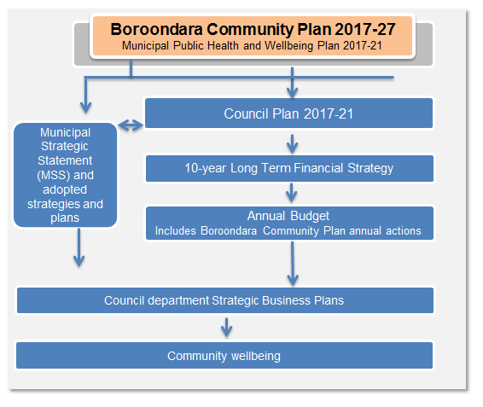

The BCP will be implemented through our Annual Commitments set out in the Annual Budget.

This integrated planning approach provides a line of sight through every department in Council to the community vision and wellbeing commitment to achieve the community’s long-term outcomes, whilst allowing our organisation and our partners to adapt and prioritise strategies and actions that are responsive to community needs as they emerge and change over time.

Evaluating and Refreshing the Plan

To ensure the BCP continues to meet community needs, we have developed a comprehensive evaluation framework to monitor our progress and report on the success toward achieving the strategic objectives and strategies set out in the Plan.

Reporting will be incorporated into the City of Boroondara Corporate Reporting Framework, which presents a comprehensive picture of our performance. The evaluation framework includes a set of outcome and output indicators. Outcome Indicators assess the overall impact and achievement of the strategic objectives, while the output indicators will measure specific activities. Indictors will be used from the Boroondara Community Satisfaction Survey, the Local Government Reporting Framework (LGPRF) and operational indicators included in the Council Plan and for the first time we will report on outputs delivered by groups and agencies, which are funded by or located in facilities provided by Council. To ensure accountability and transparency, we will:
- publish the annual commitments in the Council Budget and report on the progress in the Annual Report
- actively consult the community through various channels including the annual Boroondara Community Satisfaction Survey to measure community satisfaction of our seven priority themes.
Health and liveability indicators will also be monitored in order to understand the influence our efforts have on the health and wellbeing of our community, using local, regional and state level data in line with the Victorian Public Health Outcomes Framework.

The table below represents a high level overview of how we will track our progress on the outcome and output indicators for each of the seven priority themes. The comprehensive set of indicators will be published in the adjusted Council Plan 2017-21 and will be reported against in the Annual Report.

Table 1: Overview of evaluation measures
Theme 1: Your Community, services and facilities
Strategic Objective 1: Community Services and Facilities are high quality, inclusive and meet a variety of needs now and into the future.
Outcome indicators
Indicators | Data source
Access to community services and facilities | - Data collected from Council’s services and facilities
Satisfaction with community services and facilities | - Annual Community Satisfaction Survey
Council funded services and activities delivered by community groups | - Numbers of Council funded grant recipients and funded agencies
Utilisation of Council’s facilities, leases and licenses | - Numbers of community groups using council facilities
Output indicators
Range of indicators to assess the progress of access, appropriateness, quality and cost of community services and facilities | - LGPRF measures  - Operational indicators
Theme 2: Your Parks and Green Spaces
Strategic Objective 2: Inviting and well-utilised community parks and green spaces
Outcome indicators
Indicators | Data source
Satisfaction with parks and green spaces | - Annual Community Satisfaction Survey
Output indicators
Range of indicators to assess the progress of access, appropriateness, quality and cost of parks and green spaces | - LGPRF measures  - Operational indicators
Theme 3: The Environment
Strategic Objective 3: Our natural environment is healthy and sustainable for future generations.
Outcome indicators
Indicators | Data source
Environment scorecard | - Data collected from Council’s services and facilities
Output indicators
Range of indicators to assess the progress of access, appropriateness, quality and cost of environmental practices | - LGPRF measures  - Operational indicators
Theme 4: Neighbourhood Character and Heritage
Strategic Objective 4: Protect the heritage and respect the character of the City to maintain amenity and liveability whilst recognising the need for appropriate, well-designed development for future generations.
Outcome indicators
Indicators | Data source
Satisfaction with neighbourhood Character and Heritage | - The volume and content of complaints received (excluding objections to planning permit applications)
Output indicators
Range of indicators to assess the progress of access, appropriateness, quality and cost of neighbourhood Character and Heritage | - LGPRF measures  - Operational indicators
Theme 5: Getting around Boroondara
Strategic Objective 5: Travel options that are connected, safe, accessible, environmentally sustainable and well-designed.
Outcome indicators
Indicators | Data source
Satisfaction with Getting around Boroondara | - Annual Community Satisfaction Survey
Output indicators
Range of indicators to assess the progress of access, appropriateness, quality and cost of Getting around Boroondara | - LGPRF measures  - Operational indicators
Theme 6: Your Local Shops and Businesses
Strategic Objective 6: A vibrant local economy and shops that are accessible, attractive and a centre of community life
Outcome indicators
Indicators | Data source
Satisfaction with local shops and business | - Annual Community Satisfaction Survey
Output indicators
Range of indicators to assess the progress of access, appropriateness, quality and cost of local shops and business | - Operational indicators
Theme 7: Civic Leadership and Governance
Strategic Objective 7: Ensure that ethical, financial and socially responsible decision making reflect community needs and are based on principles of accountability, transparency, responsiveness and consultation.
Outcome indicators
Indicators | Data source
Satisfaction with Civic Leadership and Governance | - Annual Community Satisfaction Survey
Output indicators
Range of indicators to assess the progress of access, appropriateness, quality and cost of Civic Leadership and Governance | - LGPRF measures  - Operational indicators

The BCP will be reviewed each council term (4yrs) to ensure alignment with new trends, demands and changes to community and government priorities. Community engagement, demographic research and other service research will contribute to the Plan’s review, with community engagement activities focussed on how the commitments have been met and residents’ emerging and new priorities.

In 2021, we will refresh and update the plan in line with the new council term.

Partnerships
It is our responsibility to ensure the effective delivery of this community plan. To achieve this, the BCP will require collaborative partnerships between Council and a range of stakeholders including community members and groups, service providers, businesses and State and Federal Government organisations.

To support this approach, our partners will be able to work with us in a number of ways including membership on Council’s advisory committees, partnering on regional working groups, and providing feedback and submissions on specific projects through public exhibition and consultation. This will enable Council and our partners to ensure we are working with the best available information and coordinating our efforts for a greater impact on the outcomes we are aiming to achieve.

In addition to these partnership opportunities, we will also convene a Municipal Public Health and Wellbeing Plan 2017-21 Advisory Committee, which will provide advice on the implementation of the legislative requirements of a Municipal Health and Wellbeing Plan. This will provide the opportunity for key stakeholders to identify areas for joint action and to provide advice about the implementation of community health and wellbeing actions. Key members of the advisory committee will be our health promotion funded organisations: Department of Health and Human Services, Access Health and Community, Inner East Primary Care Partnership, Women’s Health East and East Melbourne Primary Health Network.

Partnership actions will be implemented through a range of strategic plans and actions across Council.

Keeping in touch with the community
Our community plays a key role in the implementation of the BCP, and will be able to have their say through a range of forums including advisory committees of Council, and by participating in consultation activities on draft Council policies and strategies.

We will provide opportunities for the community to provide feedback on our progress against the community plan and to participate in consultation at the beginning of each council term to ensure it remains relevant over the next 10 years.

We look forward to your continued involvement with the BCP.

Acknowledgements
We would like to thank and acknowledge the thousands of people who told us what was important to them about Boroondara. Children, young people and adults from right across Boroondara gave their views via postcards, at meetings, over the phone and online with enthusiasm and passion for our community’s future.
Thanks also go to staff from community groups and organisations who worked with our community to make sure as many voices as possible were heard to develop our community plan.

Appendix 1

Responsibilities under the Public Health and Wellbeing Act

The Public Health and Wellbeing Act 2008 states that a Municipal Public Health and Wellbeing Plan must have regard to the Victorian Public Health and Wellbeing Plan 2015-19, and to report on measures to prevent family violence and respond to the needs of victims of family violence in the local community. The Climate Change Act 2017 also states that Council must have regard to the potential impacts of climate change through any decision made or action taken through the provision of the Public Health and Wellbeing Act 2008.

Through the implementation of the BCP, we will have regard to the strategic directions set out in the Victorian Public Health and Wellbeing Plan 2015-19 and will adopt the following components to address health and wellbeing:
- improvements at every stage of life
- place-based approaches
- promoting health and wellbeing, in particular through improving mental health, preventing violence and injury, reducing harmful alcohol use and promoting healthier eating and active living.

Council will also have regard to our responsibility in relation to climate change to provide leadership and good governance as set out in the section 17 of the Victorian Climate Change Act 2017. We will do this through the implementation of a large number of strategies that can be broadly captured by the following directions:
- protecting and preserving our trees, nature and open space
- showing leadership in reducing the environmental impact of our facilities and services, such as through incorporating environmental design principles
- providing support to the community to reduce their environmental impact through reduced waste generation and sustainable living projects.

Council will also have regard to the recommendations of the Royal Commission into Family Violence by working with our community and partners to address and prevent family violence by:
- designing and supporting safe facilities and public environments for all
- promoting and supporting the participation of girls and women in all areas of community life, Council services and facilities through respectful and inclusive practices to improve equity
- creating strong neighbourhoods that promote respectful and supportive social connection
- ensuring Council services are equipped to respond, where appropriate, to all forms of family violence.
- working with partners to address family violence and initiatives which can contribute to a community that values equality and respect.

Demographic information is from the Census of Population and Housing 2016 unless otherwise specified.
id Consulting 2017, City of Boroondara population forecasts
id Consulting 2017, City of Boroondara population forecasts
Australian Bureau of Statistics - Estimating Homelessness 2012
Data about our economy is from id Consulting City of Boroondara economic profile 2017 unless otherwise specified.
City of Boroondara, Economic Development & Tourism Strategy (2016 - 2021)
2014 Victorian Population Health Survey
2015 VicHealth Indicators Survey
Turning Point 2017
Victoria Police 2016
Crime Statistics Agency 2015
Victorian Injury Surveillance Unit 2015
Department of Health and Human Services 2015

