Integrated Water Management Strategy
Implementation Plan 2017–2019

Responsible Directorate: Environment and Infrastructure
Authorised By: Chief Executive Officer
Date of Authorisation: 4 May 2017
Sunset Date: June 2019

Table of contents
1. Purpose 3
2. Background 3
2.1. IWMS vision, guiding principles and objectives 3
2.2. 2017-19 Plan structure 4
3. Progress highlights from the Implementation Plan 2014–16 4
3.1. Construction of the Grace Park Raingarden in Glenferrie 4
3.2. Municipal-wide assessment of Water Sensitive Urban Design (WSUD) opportunities 5
3.3. Chandler Park Wetlands - design and community consultation 6
4. 2017–19 action plan 8
5. Complementary ongoing activities 14
6. Monitoring and reporting 14

For all queries or feedback regarding this document, please contact the Principal Sustainability Officer (Water), Environment and Sustainable Living Department, by calling (03) 9278 4011 or email environment@boroondara.vic.gov.au

Purpose
The Integrated Water Management Strategy 2014–2024 (IWMS) was adopted by Council on 26 May 2014. The IWMS aims to better integrate the City of Boroondara’s approach to water cycle management and seek solutions that deliver multiple benefits to Council, the community and the environment.

An initial IWMS Implementation Plan 2014–16 (endorsed by CEO under delegation in November 2014) outlined priority initiatives to lay the foundation for longer-term investment in integrated water management consistent with the Strategy’s vision and objectives.
This new IWMS Implementation Plan 2017–19 builds upon the previous plan and outlines priority and capital works to be carried out over the coming years. Some actions are subject to project authorisation and/or adequate funding being available.
This Implementation Plan 2017–19 concludes at the mid-point of the ten-year strategy, which will coincide with a review of the IWMS targets and implementation planning for the second half of the strategy term. This Implementation Plan is to be read in conjunction with the IWMS (available to download from www.boroondara.vic.gov.au/water).

Background

IWMS vision, guiding principles and objectives
The Strategy’s vision is for “…a healthy, green and resilient city…where a diversity of water sources is available so that the right quality of water is available when and where it is required…contributing to healthier waterways and open spaces for greater community well-being.”

A set of six guiding principles have also informed the objectives of the IWMS and will guide the implementation of the strategy, being:
- Valuing water - water is one of our most valuable resources not only for drinking but also protecting our local amenity and valuable urban ecology.
- Partnership approach - partnering with project beneficiaries to co-fund implementation actions is critical to realising the aspirations of this strategy.
- Balance competing objectives and pursue multiple benefits - the IWMS should be implemented in a way that maximises community well-being and other potential co-benefits (social, environmental, financial).
- Leadership by Council within the community - demonstrating commitment and leadership to the community, key stakeholders, other councils and Council staff.
- Action prioritised by impact - prioritise actions according to greatest social, environmental and economic benefit per dollar of Council funds invested.
- Consider the impacts of climate change - it’s important that we plan ahead to ensure greater resilience to expected heatwaves, droughts, floods and storms.

The vision is supported by four overarching objectives that provide a framework for action over the next decade. These objectives are:
- Minimise use of drinking water.
- Increase local water harvesting and fit-for-purpose reuse.
- Remove pollutants contaminating our stormwater before it enters our waterways and Port Phillip Bay.
- Support Council’s flood mitigating activities in a way that better protects properties from flooding while also protecting the environment, amenity and function of Council assets.
The IWMS contains a range of interrelated strategies that have the potential to achieve the four overarching objectives, and associated targets, within the IWMS.

2017-19 Plan structure
As the second Implementation Plan of the ten-year IWMS timeframe, this document highlights progress from the first IWMS Implementation Plan 2014–16 (see Section 3) and then outlines priority actions for delivery during 2017 to 2019 (see Section 4) grouped under categories of:
- Public open space, parks, gardens, and sports grounds
- Private land use planning and development
- Council buildings
- Community engagement.
High priority actions under each of these categories are delegated to a responsible department, noting timeframe and resourcing implications as well as the objective(s) within the IWMS that the action contributes towards achieving.
A number of other activities, undertaken within existing resources on an ongoing basis, or as actions within related plans, will also support the delivery of the IWMS objectives and are included in the ‘Complementary activities’ (see Section 5) of this document.

Progress highlights from the Implementation Plan 2014–16

Most actions outlined in the IWMS Implementation Plan 2014–16 are now complete or well progressed. Highlights from the initial two years of IWMS implementation are profiled below.

Construction of the Grace Park Raingarden in Glenferrie
Project description | 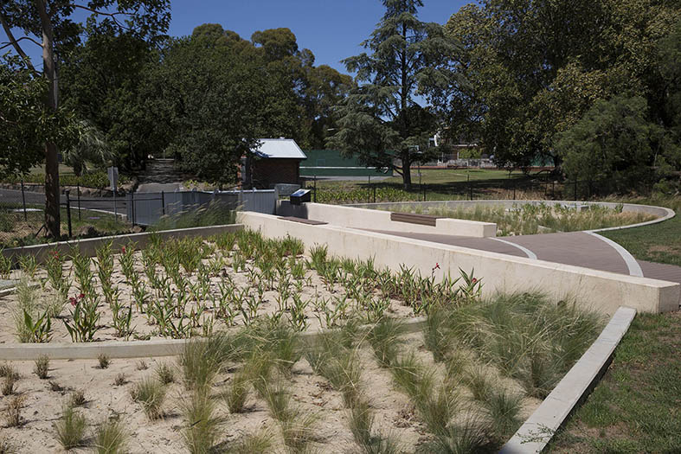  Installed in 2016, the Grace Park Raingarden is the first major stage of the Glenferrie Water Management Plan to provide a more secure and sustainable water source for this popular recreation precinct.  The system diverts stormwater from the Hawthorn Main Drain and then pumps it through the raingarden – which removes pollutants through bio-filtration – before the water is harvested for reuse.  The treated stormwater is stored in a 220 KL underground tank, before being used for watering within Glenferrie Oval and Grace Park.  The water storage is also connected to a water truck refill point in Power Street to allow water to be transported to other Boroondara public spaces for irrigation. Any surplus treated water is returned to the broader river system via the main drain.
Community benefits | Local sustainable water supply:  The system will supply up to 37ML per of treated stormwater for reuse at 87% reliability, and will save 23 ML/yr in drinking (potable) water to meet local demand. The treated water will be used for park and oval irrigation, municipal street tree watering, and tennis court watering.  Greener, healthier parks and street trees:  Access to this local sustainable water source is enabling expanded irrigation of Grace Park (to protect the health of trees and vegetation) and watering of street trees, particularly during periods of dry weather. The project involved planting some 2880 new plants, increasing plant diversity and provision of ecosystem services (environmental services such as plant pollination, air filtration, pollution treatment, stormwater management and carbon sequestration).  Less pollution to local waterways:  The bio-filtration within the raingarden will remove excess nutrients and other pollutants from stormwater that flows to the Yarra River and Port Phillip Bay. Each year, the system is modelled to stop 97kg of Nitrogen and 8kg of Phosphorus, 4787kg of suspended solids and 1474 kg/year gross pollutants from entering local waterways.  Enhanced park amenity:  Improved open space amenity and park experience of an attractive planted rain garden.  Preserving local heritage and landscape values:  The heritage and landscape values of the established trees and vegetation in Grace Park will be preserved by providing a sustainable source of water for irrigation. The landscape will be more resilient to drought and heatwaves, helping to keep the precinct cooler during hot weather.  Community education and local government leadership:  Interpretation signage has been installed on site with information on how the system works and its benefits. Council officers are hosting a guided tour and presentation about the project for Clearwater (local government IWM capacity-building program).
Delivery partners | - Victorian Government - $1,000,000 funding contribution  - Melbourne Water, Living Rivers Program - $200,000 funding contribution  Total project capital cost $1.6M

Municipal-wide assessment of Water Sensitive Urban Design (WSUD) opportunities
Project description | During development of the IWMS in 2013/14, specialist consultants DesignFlow identified some 21 opportunities (sites) for potential creation of WSUD assets - that is, wetland or raingardens, sometimes with associated water harvesting for reuse - on public land across the municipality.  During 2014/15 a multi-criteria assessment (MCA) framework was developed to weigh a broad range of social, economic and environmental considerations to better understand the feasibility and relative priority of the 21 opportunities. The study recommended five opportunities (sites) as highest priority to progress in the short- to medium-term:  - Chandler Park, Kew (wetland)  - Gordon Barnard Reserve, Balwyn North (raingarden with harvesting/reuse)  - Macleay Park, Balwyn North (raingarden with harvesting/reuse)  - Boroondara Park Camberwell (raingarden with harvesting/reuse)  - Muir Street Park, Hawthorn (raingarden)  As a result, design for the Chandler Park Wetlands project is progressing to completion (see section 3.3 below) and concept design for WSUD projects at Gordon Barnard Reserve and Macleay Park commenced in early 2017.
Community benefits | The MCA study enabled officers from across relevant Council service areas to contribute to an assessment of potential WSUD projects against a holistic framework of tangible and intangible costs, benefits and risks. Community / social considerations within the assessment framework included:  - Impact on existing users  - Public safety  - Amenity and aesthetics
Delivery partners | - Specialist consortium - Aither (economists) with DesignFlow (WSUD engineers)  - Melbourne Water, Living Rivers Program - $90,000 funding contribution

Chandler Park Wetlands - design and community consultation

Project description | 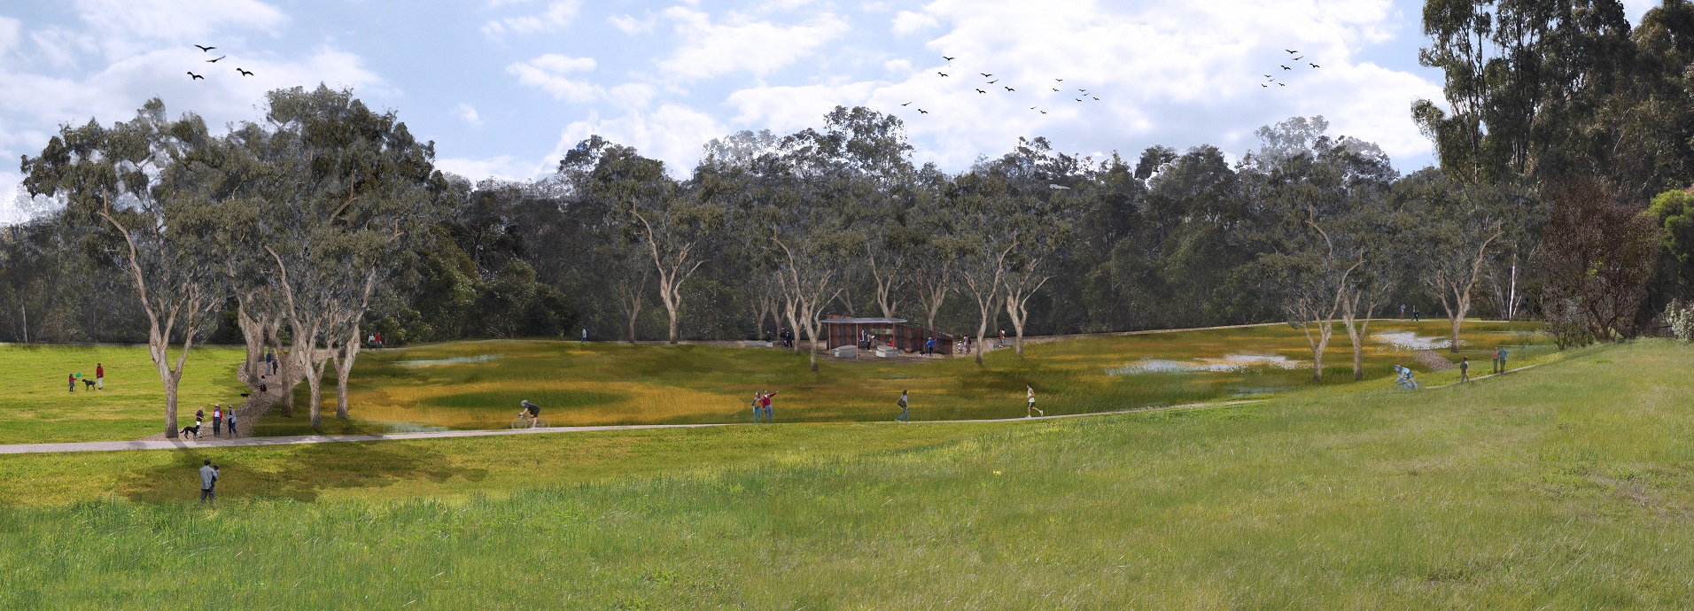  Once Chandler Park in Kew was identified as a high priority WSUD opportunity (see section 3.2 above), Council commissioned conceptual plans for a constructed wetland in the eastern portion of the park.  The wetland project will divert and treat polluted stormwater from a nearby Main Drain that would otherwise flow directly to the Yarra River. It will make use of around half a hectare of grassed open space between the river and the Main Yarra Trail (shared path). The landscape design includes new recreational walking paths; additional trees and understorey plantings; a shelter, sculptural ‘bird hide’ and seating.  Community feedback on the concept plans overwhelmingly supported creation of the wetlands and associated landscaping, and their input informed the wetlands detailed design.  Pending finalisation of the detailed design and confirmation of available internal and grant funding, construction of the wetlands is proposed over the winter of 2018.
Community benefits | Landscape and recreational amenity:  The project will significantly enhance the quality and interest of the park’s open space, providing improved opportunities for walking, resting, bird watching and opportunities for connection to nature. The wetland is directly adjacent to the busy Main Yarra Trail, and proposes a new ‘figure 8’ circuit path around the wetlands. The shelter and seating provide rest areas for walkers and recreational cyclists.  Precious habitat for native wildlife:  The project’s biodiversity benefits will derive from planting of approximately 35,000 indigenous plants (incl wetland and terrestrial species) and landscape design incorporating features such as emergent stags, rock outcrops to provide additional habitat niches – for birds, frogs, reptiles, insects and microbats – enhancing the Yarra River biodiversity corridor.  Less pollution to local waterways:  Each year, the system is expected to protect waterway health by stopping an estimated 180kg of Nitrogen, 44kg of Phosphorus and 26,181kg of suspended solids from entering the Yarra River and Port Phillip Bay.  Opportunities for education and engagement with nature:  On site interpretation will provide visitors the opportunity to learn about the Yarra River, its wetland and billabong ecosystems, stories from the Wurundjeri Aboriginal community, and local wildlife. The wetlands will also provide a location for community engagement activities such as ‘twilight tours’ with the Yarra Riverkeeper and ‘bush kinder’ activities.
Delivery partners | - Design consultants - Alluvium (WSUD engineers) and Realm Studios (landscape architects)  - Melbourne Water, Living Rivers Program - $110,700 in funding grants for design and tender documentation of the wetlands.

2017–19 action plan

Department Acronyms: E&SL (Environment and Sustainable Living), P&I (Parks and Infrastructure), P&S (Projects and Strategy), SP (Strategic Planning), AM (Asset Management), FY&R (Family, Youth and Recreation).

Public open space, parks, gardens and sports grounds
Ref # | Action | When | Resourcing | Responsibility | Related IWMS Objectives
1 | WSUD Infrastructure Program - planning, design and implementation  Progress concept design, community consultation, detailed design and construction (pending funding allocation and grant income) for selected high priority WSUD sites including:  - Gordon Barnard Reserve (raingarden with harvesting/re-use)  - Macleay Park (raingarden with harvesting/re-use) | 2016/17 - concept  2017/18 - 2018/19 consult and detailed design | 2016/17 Budget: $90,000  2017/18: $100,000  2018/19:  To be confirmed pending designs | Lead: Principal Sustainability Officer (E&SL) in collaboration with P&S, P&I | Objective 2: Increase local water harvesting and ‘fit for purpose’ re-use  Objective 3: Remove pollutants contaminating stormwater before it enters our waterways
2 | Develop a Soil Management Plan and program  A best practice ‘soil profile management’ regime (including techniques such as turf ‘spiking’ and tailored application of nutrients) has the potential to maintain and/or improve the turf condition on sports fields while more efficiently using irrigation water (or rainwater) to maintain the playing surface.  A soil management trial and planning during 2016/17 will inform establishment of a Soil Management Program for progressive roll-out across suitable sports fields and gardens. | 2016/17 trial and plan  2018/19  roll-out program | 2016/17 Budget: $100,000  2018/19  Est. $100,000 - $150,000 /pa (Operating) | Lead: Coordinator Turf Management (P&I) in collaboration with Coordinator Open Space (P&I) and E&SL | Objective 1: Minimise use of drinking water  Strategy 1.2: Reduce reliance on drinking water for open space irrigation
3 | Irrigation Management Plan and renewal program  Specialist consultants will identify a framework for the sustainable management and irrigation of parks and open space; and set KPIs for water management based on efficient use, quality of open space outcomes and sustainability.  The plan will inform renewal of irrigation systems, including design, scheduling and expenditure. | 2016/17 - plan  2017/18 ongoing - renewal and upgrades | 2016/17 Budget: $80,000  2017/18 - via irrigation renewal budgets | Lead: Coordinator Open Space(P&I) in collaboration with Coordinator Turf Management (P&I) and E&SL | Objective 1: Minimise use of drinking water  Strategy 1.2: Reduce reliance on drinking water for open space irrigation  Objective 2: Increase local water harvesting and ‘fit for purpose’ re-use
4 | Grace Park recycled water irrigation system  Using sustainable water harvested through the recently completed Grace Park raingarden, install an irrigation system to support the long-term health and amenity of park trees and vegetation. | 2016/17 | 2016/17 Budget: $210,000 | Lead: Coordinator Open Space(P&I) | Strategy 1.2: Reduce reliance on drinking water for open space irrigation  Objective 2: Increase local water harvesting and ‘fit for purpose’ re-use
5 | Chandler Park Wetland - detailed design and implementation  Complete detailed design documentation for tender, including integration of ‘Stage 2’ wetland area, and seek/secure co-funding for project implementation.  Pending funding confirmation, construct the water quality treatment wetland, with associated amenity and habitat landscaping. | 2016/17 - update detailed design for tender  2017/18 - 2018/19 - construct | 2016/17 Budget: $50,700  (incl $30,700 grant income Melbourne Water)  2017/18 - 18/19 foreshadowed: $1.2M  (incl $500k grant income - pending) | Lead: Principal Sustainability Officer (E&SL) for design, in collaboration with P&S for construction, and P&I for operation | Objective 3: Remove pollutants contaminating stormwater before it enters our waterways  Strategy 3.5 Engage local residents in removing pollutants from our stormwater
6 | Review and establish programs for WSUD asset (raingardens and wetlands) maintenance and renewal  Review and build on Council’s internal capacity and processes (technical expertise, resource allocation, operational processes/guidelines etc) to cost effectively maintain and renew existing and new WSUD infrastructure for sustained performance and co-benefits. | 2017/18 - ongoing | 2017/18  $103k/pa (Operating) | Lead: Coordinator Biodiversity Sites (P&I) via a working group with P&I, AM and E&SL | Objective 3: Remove pollutants contaminating stormwater before it enters our waterways  Strategy 3.2 Build and maintain Council’s internal capacity
7 | Implement Bolin Bolin stormwater harvesting project at Freeway Golf Course  An open water storage dam constructed between the 14th and 15th holes at Freeway Golf Course will store harvested water for golf course irrigation. This is part of the larger Bolin Bolin integrated water management project (led by the City of Manningham). | 2016/17 | 2016/17 Budget:  $300k | Lead: Coordinator Turf Management (P&I) | Objective 2: Increase local water harvesting and ‘fit for purpose’ re-use  Objective 3: Remove pollutants contaminating stormwater before it enters our waterways
8 | Investigate opportunities to develop a water feature at Maranoa Gardens that incorporates WSUD and other water saving initiatives  This project responds to philanthropic funding offer and will align with the Irrigation Management Plan and renewal program (Item 3 above). | 2016/17 - 2017/18 | Est. $30,000 | Lead: Manager Environment and Sustainable Living | Objective 2: Increase local water harvesting and ‘fit for purpose’ re-use  Objective 3: Remove pollutants contaminating stormwater before it enters our waterways  Strategy 3.5 Engage local residents in removing pollutants from our stormwater

Private land use and development/planning
Ref # | Action | When | Resourcing implications | Responsibility department(s) | Related IWMS Objectives
9 | Complete flood modelling and mapping of Boroondara catchments, including consultation.  This work will confirm flood risk areas and provide the foundation for future flood management planning and response, including:  - Council’s drainage renewal program.  - Emergency planning and preparation.  - Revised land use /planning advice, and potential planning scheme amendment (Special Building Overlay update). | 2016/17 | 2016/17 Budget: $100,000  Further budget of $120,000 to $180,000 will be required if Council decides to undertake a planning scheme amendment for a new or updated SBO. | Lead: Team Leader Drainage Strategy (P&S) in collaboration with SP, AM, P&I and E&SL | Objective 4: Support flood mitigation activities to protect properties, the environment, amenity and assets.
10 | Promote water sensitive opportunities via permit processes  Review and update processes, procedures and support material to further promote water efficiency, rainwater harvesting and reuse measures within private developments (via building and planning permit process). | 2016/17 - 2018/19 | Within existing resources | Lead: Principal Sustainability Officer (E&SL) in collaboration with Statutory Planning and Building Services. | Objective 1: Minimise use of drinking water  Objective 2: Increase local water harvesting and ‘fit for purpose’ re-use
11 | Investigate and pilot (if feasible) emerging options to reduce gross pollutants entering drainage  Investigate the feasibility of piloting patented ‘Stop Ocean Pollution’ curb filters (or similar treatments) in one or more Boroondara shopping strips. Co-benefits to be confirmed include:  - Reduced blockage of pits / pipes  - Reduced drainage maintenance costs | 2017/18 -investigate/plan  2018/19 -  pilot (pending business case) | 2017/18 Budget: within existing resources  2018/19: TBC via investigation, will seek grant co-funding for pilot | Lead: Principal Sustainability Officer (E&SL) in collaboration Coordinator Cleansing and Drainage (P&I) and P&S | Objective 3: Remove pollutants contaminating stormwater before it enters our waterways
Council buildings
Action # | Action | When | Resources | Responsibility | Related IWMS Objectives
12 | IWMS Facility Retrofit Program - planning and implementation  The program identifies and implements highest impact for lowest cost actions in facilities or plant that are not scheduled for renewal in the medium-term.  Example actions include retrofit of water efficient fixtures, fittings and appliances, building plant, rain tanks. | 2016/17 - 2018/19 | $50,000 / pa | Lead: Principal Sustainability Officer (E&SL) in collaboration with FY&R and P&S, P&I | Objective 1: Minimise use of drinking water  Strategy 1.1: Progressively improve water efficiency of Council buildings  Objective 2: Increase local water harvesting and ‘fit for purpose’ re-use

Community Engagement
Action # | Action | When | Resources | Responsibility | Related IWMS Objectives
13 | Develop and deliver community engagement resources and activities  Partner with key stakeholders such as Yarra Valley Water, Melbourne Water and Yarra Riverkeepers in activities that engage local residents and businesses to increase water literacy and adoption of water sensitive practices, including:  - Rainwater tanks, plumbed for internal use  - Water efficient whitegoods, fittings, fixtures  - Water-wise landscaping and gardening  - Grey water irrigation systems  - Raingardens and ‘green roofs’  - Appropriate disposal of waste liquids | 2016/17 - ongoing | $10,000 allocation within Operating budget | Lead: Principal Sustainability Officer (E&SL) in collaboration with external and internal stakeholders | Objective 1: Minimise use of drinking water  Objective 2: Increase local water harvesting and ‘fit for purpose’ re-use  Objective 3: Remove pollutants contaminating stormwater before it enters our waterways

Complementary ongoing activities
In addition to the above high priority actions, a range of activities are being undertaken by Council to support delivery of the IWMS. These continuous improvement activities will be delivered within operational resourcing or incorporated into planned projects, for example:
- Implement the Sustainable Council Buildings Policy (2016) - the Sustainable Council Buildings Policy sets out clear commitments for achieving improved sustainability standards in the way Council’s buildings are planned, designed, built, used and maintained. It defines Green Star 5-Star (or equivalent) as the minimum sustainability standard to be achieved for all significant new buildings, upgrades/expansions and building renewals.
- Drainage Asset Management Plan - further refine and implement the Drainage Asset Management Plan, in particular actions relating to WSUD asset management.
- Collaboration and information sharing - with delivery partners such as Department of Environment, Land, Water and Planning (DELWP) and Melbourne Water on strategic initiatives (for example, regional Integrated Water Management Forums and development of Yarra River Strategic Plan).
- Advocacy - advocating to Victorian and Commonwealth Government and related agencies (eg. Melbourne Water, Parks Victoria, EPA etc) for more supportive policy, regulation and programs to progress ‘water sensitive cities’ principles and outcomes. Advocacy priorities include:
- Increased funding support for development of WSUD infrastructure (eg stormwater harvesting, treatment and reuse) and amenity enhancements along the Yarra open space corridor
- More ambitious objectives and targets for the Yarra River and bay health
- Stronger WSUD policy and regulatory support within state planning provisions and building/construction regulations.
- Water pricing and institutional reform to support supply from alternative (non-potable) sources and put downward pressure on potable demand.
- Timely revision of regional flood mapping and management with consideration of longer-term climatic projections.
- Monitoring - continue to install and monitor data from smart water meters across Council facilities to identify water saving opportunities and support the effectiveness of water re-use systems.
- Accessing industry research and networking - continue to support industry partners and be active members of collaborative industry associations. Council is an industry partner in the 10 year CRC for Water Sensitive Cities program, contributing $10,000 annually towards funding the program.

Monitoring and reporting
Monitoring involves collection and analysis of data and information to assist timely decision-making, ensure accountability and provide the basis for assessing progress toward achievement of objectives and targets. It helps identify if adjustments need to be made to strategies, targets, resourcing or project design.
Section 8 of the IWMS includes proposed progress indicators for the first three objectives of the Strategy, and the data that is being collected to track progress against these indicators.
The IWMS 2024 targets will be reviewed at the mid-point of the IWMS implementation timeframe (that is, 2018/19). This review will take into account new information and outcomes from key projects, and any revision to targets will be reflected in the subsequent Implementation Plan.
The actions listed in Section 4 of this Plan will be entered into Council’s reporting system Interplan and reported on annually.

