Background

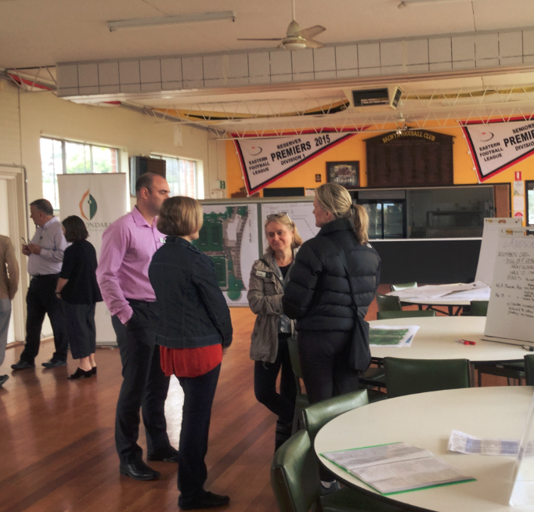
In 2013, through an extensive community engagement process, the City of Boroondara prepared a Concept Master Plan for the redevelopment of Balwyn Park.

The delivery of the Master Plan was proposed as a multiple stage project, with the first stage being to convert the unused former bowling greens and pavilion into four tennis courts, construct a new tennis club house and space for community groups and improve the amenity of the outdoor spaces.

Council consulted key user groups from mid-2015 to mid-2016 and developed a draft concept design for Stage One.

With funding for Stage One of the project secured, Council contacted local residents to obtain feedback to inform the concept design.

Communications and engagement

In early November 2016 letters were sent to residents of the 17 properties adjoining the tennis courts as well as residents of an adjacent block of apartments inviting them to contact Council to meet to discuss the project personally. The letters also invited them to attend an information session with Council staff and acoustic and lighting engineers.

Two residents contacted Council via phone, but neither opted to meet prior to the information session.

Letters were also distributed within a 500m radius of the reserve notifying residents of the project and inviting them to attend the community information session.

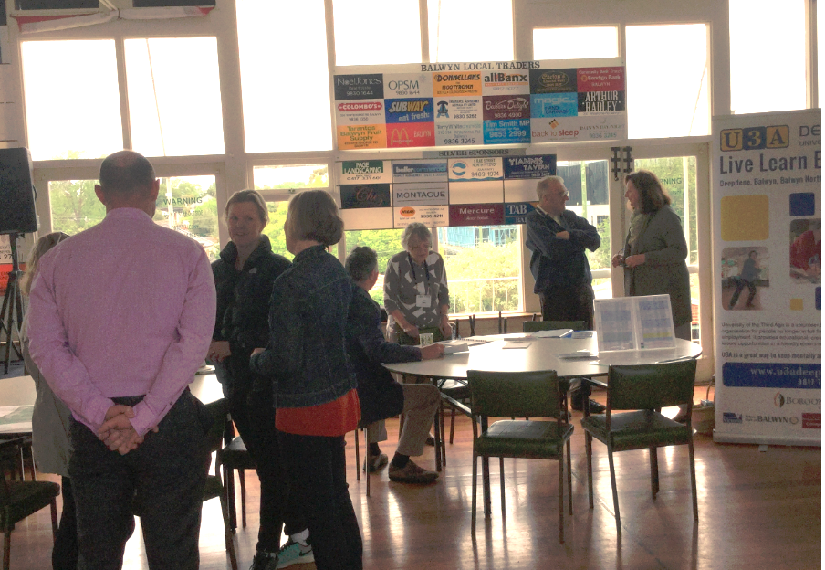
The information session on 26 November 2016 from 11am to 2pm attracted approximately 25 to 30 attendees. Council officers, Cr Jane Addis and Cr Cynthia Watson were in attendance.

Information about the design of the new building, acoustic and lighting impact on properties adjoining the tennis courts, trees, landscaping and the Balwyn Park Concept Master Plan was on display, with experts in attendance to answer questions.

Respondents

There were two ways attendees of the information session could submit feedback; on butchers paper or feedback forms. Some attendees used both methods and some people included multiple comments. Feedback was sought prompted by the request “Please provide any feedback you have on the proposed plans for the Balwyn Tennis and Community Facility”

Feedback forms - 13 people
Butcher’s paper - 5 people

In addition to providing feedback, 15 people requested to be kept informed.

See Appendix 1 and 2 for comments.

Feedback

In response to the prompt “Please provide any feedback you have on the proposed plans for the Balwyn Tennis and Community Facility”; the feedback forms and butcher’s paper elicited 53 comments over 16 themes. As the number of participants was low, the themes and comments are represented in the table below:

Comment theme | What’s included | Responses
Ideas for improved reserve facilities and planting | Rubbish bins, drinking fountains, running track, exercise equipment for seniors, dog bowls, drinking fountains, bins, planting proposals for hedges and flower beds | These suggestions are outside the scope of this project stage.  The process of the Concept Master Plan included extensive consideration of broader infrastructure. The Council Approved final plan included all elements noted here, except a running track. Council officers will liaise with this individual separately.  All infrastructure elements noted in the Concept Master plan will be considered in subsequent project stages.  Communications about future project stages will include relevant infrastructure
Support for facility proposed | Good planning, use of space, development will be an asset to the community, building looks good, likely to increase use, support U3A being included, aesthetics, use of space, inclusion of U3A an asset | Support acknowledged. The Master Plan identified that the bowls facility requires demolition and replacement to be fit for purpose into the future.
Parking and access concerns | Concerns about pressures on parking due to extent of development in area (residential and commercial) and access to the site. Request to clarify construction parking arrangements, request to close Cherry Rd (northern end) entrance to Balwyn Park. | The process of the Concept Master Plan included extensive consideration of parking and access, concluding that no additional parking would be required and including closure of the northern internal road to Cherry Rd.  Further communications about this project stage will include parking arrangements during construction
Incorporate rebound wall into redevelopment | Inclusion of rebound wall as part of the project | A small rebound wall is planned for inclusion within the tennis court complex and will be finalised as part of the detailed design for this stage. This will be for use by club members and their visitors.  The Master Plan included a rebound wall for consideration in the activities area on the eastern edge of the park, where the tennis club currently exists, for public use. This will be considered in the next stage of the project.  Communications about future project stages will include the rebound wall
Concerns about condition of sport infrastructure | football, cricket and patrons | These suggestions are outside the scope of this project stage.  Concerns about the condition of sporting infrastructure will be provided to appropriate Council service units for their consideration and response.
Concerns about detrimental effects on reserve | Heritage, environment, noise, lighting, balls | Concerns raised will be considered further in the detailed planning for this stage. Relevant residents will be consulted with further.  Further communications about this project stage will include results of this detailed planning.
Suggestions about the need for public toilets | As stated | The Concept Master Plan includes consideration for a public toilet. The type and location will be considered as part of the detailed design for a future stage.
Suggestions for alternative uses of bowling green | Vegetable plots, public open space, ladies/men’s shed | The process of the Concept Master Plan included extensive consideration of the range of alternate uses of the bowling green.  The Council Approved final plan resolved to relocate the Tennis Club to the former Bowling Club site. Accordingly, alternative uses of bowling greens were not a consideration for this engagement.
Concerns with alcohol consumption | Monitor consumption, not appropriate in front of children | Facility management role and processes are being developed to ensure equitable access, appropriate function management and behaviour of patrons and users.
Concerns about visibility of roof | Visual impact of roof, potential for area to be reduced in favour of increased planting | Concerns and opportunities raised have been considered further and the roof line has been reduced and planting increased.  Further communications about this project stage will include results of this detailed planning.
Concerns about functions in park | Indoor activity not appropriate, noise from functions | Facility management roles and processes are being developed to ensure equitable access, appropriate function management and behaviour of patrons and users.

Project team summary

The Council Officers that participated in the communications and engagement program, to the best of their knowledge, contacted all residents affected by the project.

Letters were hand delivered to 17 properties adjoining the development and an adjacent block of apartments, inviting them to discuss the project in more detail with the Project Manager. Most residents preferred to attend the public information session to gain more information and provide feedback rather than meet individually with the project manager.

The number of attendees at the information session was similar to the number who attended the Balwyn Park Concept Master Plan consultation in 2013.

In conversation with attendees, the overall attitude was positive toward the project and design proposal with clear interest in the design detail and the activities once the building was completed.

Relatively few attendees were negative about the proposal.

There were a number of issues that were raised by attendees which were outside the scope of the design consultation. These are included in the “Response to themes raised” table in Appendix 1.

Conclusion

Across both forms of feedback, the most frequently raised themes consisted of suggestions for improving the park, rather than the proposed design itself, including suggestions for passive and active (both formal and informal sport) infrastructure, planting and parking. There was clear support for the proposed design; however some concerns were also evident including impact on parking, alcohol and functions in the reserve building. These concerns were predominantly raised in relation to the potential management of the facility and highlight the fact that Facility Management Models need to be carefully considered

Based on the identified themes and individual feedback the following alterations to the design will be considered by the project team and architects;

- Planting increase
- Parking provision
- Reduction in roof line
- Potential changes to fencing pending discussions with relevant neighbours

Alongside this the Facility Management Model will also require careful consideration

Next Steps

The project will proceed onto the next stage being detailed design and documentation.

Everyone who asked to be kept informed, along with immediate neighbours, has been updated on the outcomes from the consultation process and sent further information about the project.
This will include updated plans and a response to the common themes identified as well as proposed timelines

More information:

To find out more about this project, please contact

Warwick Tempany (project manager) on 9278 4444 or
Warwick.tempany@boroondara.vic.gov.au
Appendix 1

Feedback form verbatim comments
- Note - some respondents wrote multiple comments
New facility looks great and a good way to utilise an awkward Council space
The location of the existing courts would be well utilised as a public space
The old tennis club has had a rebound/hit wall which has been well used by local kids. Is it possible to get this incorporated into the redevelopment
Exclusive use of any building not given to only Rotary, Probus, Lions etc. In other words local citizens and or local community groups to have equal right of use
Due to low numbers and reduced use, suggest tennis area to stay in same place however modernised
Would like to see an imitation grass running track around perimeter of the oval
Would like to see low level exercise equipment suitable for seniors
Northern end (Cherry Rd entrance) should be blocked re car use on perimeter of oval road
Players (some) of both clubs use as a racetrack.
Some sort of toilet facility perhaps backing on to tennis court facility, Cherry Rd side
suggest vegetable plots at old bowling greens possible men’s and ladies shed
Police!!! Amount of alcohol consumed at football and cricket evening / late day
The new facility looks fantastic and I think it will be a great asset to the local community
I think it would be advantageous to have a "rebound" type wall for those smaller children learning to have a hit
A false consultation as usual False consultation
fake promises designed for election purposes and conditioning the public's mind for the next election
The public was compelled to vote for the agenda a in 2013 or face losing the bowling land to private enterprise we were told
Promise of change
Pure theatre - all of it.
Few or no public attended.
As well, this agenda will bring severe wreckage to our environment and historical areas
This is a small matter - overall I am very impressed with the careful and thorough planning of this facility
Thank you for this opportunity to comment. I would like to be able to have closed access to the kitchen from MP 1.3 etc. I appreciate that a servery is planned between these two rooms but anyone wishing to carry food to the MP room would have to do it via the side doors presently U3A Deepdene hosts luncheons and receptions which require substantial catering and direct access to the room/ rooms would be desirable the smaller kitchenette would not be equal to the food preparation required for these functions
Don’t forget a rebound wall for the general public as well as the tennis club
Looks as though your proposed overall plans should be very good. With an extra court, good facilities and online booking can imagine our numbers could grow and heavier use of courts ensuring for tennis club. U3A addition could be a good one also
I think the proposal put forward is terrific. I love the tennis courts and the building design and can’t wait for the development to finish so we can use it
Our property is at (address and location removed). I am concerned about the roofed outdoor area - the roof is the section that would be visible from surrounding houses
I am concerned there is a function centre in a park as there is now, This indoor activity is inappropriate for a park which is primarily an outdoor facility
Is there any provision for construction parking? The surrounding streets area already clogged with all day parkers. This will become worse with the cinema expansion and other construction already planned for Whitehorse Rd.
I am concerned that there will be a liquor license - as this is now. This makes for constant noise from the park during functions. I also don’t agree with liquor being consumed when children are present and its association with sport.
Dog of leash!!! This is my leisure activity, walking the dog. Top oval is safe as it is bordered on 3 sides
drinking fountains and dog bowls
coaches boxes - vandalised, broken
signs: footy - pavilion
cricket - park bins used by club
outdoor gym equipment
park lighting - safety
lift - pavilion not accessible
toilets - lack of toilets for footy patrons
I am very concerned about this new master plan. My concerns are noise, lights, fencing, balls coming over and breaking windows and I also think it will affect my resale of my unit. And I also want (staff) to come and see what my concerns are and how close my unit is to this new plan
And of course parking. The council needs to do something about parking, especially now I hear that that the Balwyn Cinema is intending to have more screens
Hedge - would like to keep rear hedge to be trimmed where necessary. who will maintain this hedge - happy if hedge gets replaced by another hedge (if necessary only)
Prowse Ave - access to oval - has reduced car parking in street - given furniture pedestrian only in park will have impact ton parking in street
Please look at replacing a tennis hit up wall as part of the scheme. It is really an important space for little people to experience tennis and sport in a safe environment. The space and wall that did exist was really great for little people, being enclosed with a gate.

Appendix 2
Butchers’ paper comments
- Note - some respondents wrote multiple comments

Landscaping / External
- Southern oval - dog off lead. Many elderly cannot walk to other off lead parks (do not drive anymore)
- (address removed) No photinia hedge (want sun), native landscaping/native hedge
- (address removed) Want hedge retained
- Can covered area be reduced to allow increased planting - i.e. trees?
- Request for seats in open area facing Whitehorse road
- Loss of a good area if it goes ahead

Building
- It’s an excellent building here now. With a v. good balustrade too

General comments
- Dreadful Scrap the idea
- Awesome! Great community asset

