Rates and Charges
Deferment and Financial
Hardship Policy

Responsible Directorate: Chief Executive Officer
Authorised By: Council
Date of Adoption: 26 April 2021
Review Date: December 2025
Policy Type: Council

Table of contents
1 Introduction 3
1.1 Purpose 3
1.2 Scope 3
1.3 Corporate framework 3
2 Background 3
2.1 Policy environment 4
2.2 Policy context 4
3 Methodology 4
3.1 Consultation 4
4 Policy statement 5
4.1 Difference between a deferral and waiver 5
4.2 Calculation of interest 5
4.3 Deferring rates and charges 5
4.4 Delegation 6
4.5 Late payment of rates and charges 6
4.6 Special payment arrangements 7
4.7 Waiving of interest 8
4.8 Waiving of rates 8
5 What is not financial hardship? 9
6 Application procedure for financial hardship 9
7 Confidentiality 9
8 Implementation and monitoring 9
8.1 Accountabilities 9
9 References 10
9.1 Related documents 10
10 Counselling services 10

Introduction

Purpose
The purpose of the Rates and Charges Deferment and Financial Hardship Policy (the Policy) is to establish Council policy in relation to:
- Management of the payment of rates and charges by special arrangement;
- Applications to defer payment of rates and charges;
- Applications to have rates and charges waived; and
- Levying of penalty interest on outstanding rates and charges.
The objective of the Policy is to ensure a fair and consistent approach is applied to all ratepayers seeking financial relief from Council in regard to the payment of their rates and charges, deferring payment of rates and charges and the application of penalty interest to overdue rates and charges.
The application of fairness as a principle also applies to recognising the impact of unpaid rates on those who have paid their rates in full.

Scope
The Policy extends to all persons liable for rates and charges within the Boroondara municipality.
The Policy will be applied to all applications made to Council for alternative options for the payment of rates and charges.
A person who requires additional assistance under the Policy is defined as someone who has the intention but not the capacity to pay their account, either through lack of financial resources, or the ability to meet specific timelines.

Corporate framework
The Policy supports Council’s Mission and Vision by addressing the following objective in the Council Plan 2017-21.
Strategic objective 7 - Ensure that ethical, financial and socially responsible decision making reflects community needs and is based on principles of accountability, transparency, responsiveness and consultation.

Background
Municipal rates constitute the majority of Council’s annual income. Municipal rates are raised in accordance with the Local Government Act 1989 and provide a number of options through which payments can be made.
Council recognises managing financial hardship is a shared responsibility. Sections 170, 171 and 171A of the Local Government Act 1989 give Council the power to defer and / or waive in whole or part the payment of rates and charges if Council determines the enforcement of the requirement to pay would cause hardship to the ratepayer.
The Policy enables a person liable for rates and charges, and experiencing hardship, to make application to Council for assistance relating to rates and charges levied on a property under the Local Government Act 1989.
The Local Government Act 1989 requires that all rateable properties are issued with an annual rates and charges notice providing all options by which payments can be made.
The timely collection of rates and charges ensures adequate revenue for the provision of council services and planned capital works projects provided by Council for the community.
Council is committed to providing flexibility in its payment options including flexible special payment arrangements where financial difficulty or financial hardship is established.

Policy environment
The Policy is based on a focus of shared responsibility and delivered in a model that supports self-determination. It is believed ratepayers, given the opportunity, actively work to manage their debt, and with the appropriate support are able to better gain control of their obligations.
Council commits to working with our ratepayers to ensure they feel listened to and understood, with realistic and affordable payment arrangements established based on their individual financial situation. A holistic approach has been developed for ratepayers in financial difficulty by providing information about internal support programs as well as referrals to external agencies, where appropriate.

Policy context
To allow all ratepayers the opportunity to better manage their financial situation without adding undue stress and to ensure Council collects revenue entitlements in the interest of maintaining community services for the whole community.

Methodology
The process of developing this policy included reviewing the previous policy, actual practices and a review of other relevant polices and adopted strategies to ensure the Policy reflects the current direction of Council.

Consultation
Under the Policy consultation will be undertaken with the individual ratepayer(s) applying for assistance to ensure an appropriate payment option or rates deferral option is offered.

Policy statement
Council is committed to assisting all ratepayers who are experiencing any degree of financial difficulty or financial hardship.
Council considers:
- Financial difficulty to mean a difficulty to pay debts short term due to a change in living circumstances; and
- Financial hardship to mean a prolonged difficulty in paying living expenses, including debts, due to financial circumstances.
The Policy ensures all ratepayers regardless of their circumstances will face no judgement, and will be treated with understanding, dignity and respect with a focus on ratepayers who may be vulnerable to financial difficulties. It is a living document which will continue to evolve and be responsive to our ratepayer needs. Council is committed to continual improvement through our learning, working with partners and experts in the field of people facing financial vulnerability.

Difference between a deferral and waiver
The difference between a deferral and waiver is:
- A deferral suspends payment for a period of time; and
- A waiver permanently exempts payment of the rate and or charge under discussion.
There is no formal assessment criteria used to determine ratepayer eligibility. All ratepayers are assessed on a case by case basis and are based on a meaningful two-way conversation.

Calculation of interest
Interest is charged on overdue rates and charges in accordance with Section 172 of the Local Government Act 1989, namely:
(a) On the lump sum payment option as if the rates and charges were being paid by the four instalments option;
(b) On the four instalment payment option after the date the lump sum payment for that financial year is due;
(c) The interest is calculated at the rate fixed under section 2 of the Penalty Interest Rates Act 1983;
(d) The penalty interest rate applied to rates and charges debts of those ratepayers eligible for the pensioner rate rebate and suffering financial hardship be determined each year during Council's Annual Budget process.

Deferring rates and charges
Ratepayers may have rates and charges, or part thereof, deferred subject to the following conditions:
(a) The ratepayer must be able to demonstrate they are experiencing undue and unusual financial difficulty or financial hardship;
(b) A confidential statement must be submitted by the ratepayer as evidence of such circumstances (Appendix 1);
(c) The acceptance by the ratepayer interest will accrue on the deferred rates and charges;
(d) Where a ratepayer has complied with clauses (a) to (c) the rate or charge or part thereof may be deferred until the property is sold or transferred or the ratepayers financial circumstances improve.
It is important to note that for any rate and or charge deferred, penalty interest will continue to accrue on the debt as set out in clause 4.2 of this policy.
Administration of applications for deferment shall be the responsibility of the Coordinator Revenue and Property Services.
Monthly reports on applications received shall be provided to the Chief Financial Officer. This report should also include details of any special payment arrangements entered into under clause 4.6 of this policy.

Delegation
Unless otherwise stated, the authority to process applications under the Policy is with the Chief Executive Officer or such other person as the Chief Executive Officer approves.
Reporting on all items processed under this delegation will be provided to the Chief Financial Officer on a monthly basis by the Coordinator Revenue and Property Services.
Statistics pertaining to matters covered in the Policy shall be reported to Council through normal Quarterly Performance Report process.

Late payment of rates and charges
A grace period of seven days after the due date will be allowed on the:
(a) Lump sum payment option;
(b) Four equal instalment payment option.
Interest is not charged on instalments until after the lump sum payment is due in February of the financial year. Interest will then be charged on outstanding rates and charges but only based on the instalment amounts due to each instalment date.
If as a result of a supplementary valuation the rates and charges increase, payment of the amount due can be made interest free within two months of the supplementary valuation date or the prescribed due date for full payment, whichever is the latter.
Where a supplementary valuation and rate notice is issued one month prior to the prescribed full payment date 15 February, interest will be waived, if half the outstanding rates are paid within two months and the balance by the remaining instalment payment dates.

Special payment arrangements
Ratepayers experiencing financial difficulty or financial hardship and are unable to pay outstanding rates and charges via the full payment option, the four instalments option or the direct debit options can apply to pay via a Special Payment Arrangement, subject to compliance with the following conditions:
(a) A written payment agreement request must be completed. This can be made directly to council via email or letter or by completing a Payment agreement request for rates and charges form (Appendix 2);
(b) The acceptance by the ratepayer interest will be levied until the account is paid in full;
(c) It is preferred that the arrangement will have a limited life of not greater than 12 months following the end of the financial year the arrangement was entered into;
(d) Any default in the arrangement may end the arrangement and result in the commencement of legal proceedings;
(e) Prior to any legal action commencing the following notices will be forwarded to ratepayers with outstanding debts;
- Annual Notice in July (including comprehensive information on the notice inviting any ratepayer experiencing difficulty paying their rates to contact Council to discuss possible arrangements;
- Courtesy Reminder Notice in December;
- Final Notice in March;
- Final Demand in April; and
- Overdue Rates and Charges Letter advising of potential legal action and legal costs estimate in May and offering an option to settle the debt via a special payment arrangement.
Tenants who are responsible for the payment of rates and charges under their lease agreement can make an arrangement with Council, however they must have the approval of the owner as the owner is ultimately responsible for the rates and charges.
If after forwarding all of the notices listed above and the ratepayer has not entered into a special payment arrangement or advised Council of the reason for non-payment based on financial hardship, the matter may be referred to Council's debt collecting agency for action.
Administration of applications to commence a Special Payment Arrangement shall be the responsibility of the Coordinator Revenue and Property Services. Monthly reports on applications received shall be provided to the Chief Financial Officer.

Waiving of interest
Ratepayers may have interest charges waived where the reason for the late payment, although not related to financial difficulty or financial hardship, is considered reasonable, subject to the following conditions:
(a) The ratepayer must have a demonstrated record of payment on time (or in the case of a new ratepayer be able to demonstrate why the penalty interest should not have been charged);
(b) The ratepayer must submit a written request. This can be directly to council via email or letter or by completing an Application for waiver of penalty Interest on rates and charges form (Appendix 3);
(c) Unless otherwise approved by the Chief Executive Officer or such other person as the Chief Executive Officer approves, waiving of interest in accordance with the Policy will only be allowed on one occasion over a five year period for any ratepayer.

Waiving of rates
Sections 171 and 171A of the Local Government Act 1989 provide for the waiver of rates and charges if Council considers a ratepayer is suffering financial hardship.
Council’s policy position is not to waive rates or charges on the basis it is considered inequitable for the majority of ratepayers to subsidise the property assets of hardship applicants. A more equitable solution for the entire community is to defer rates and charges.
Council will consider the waiving or reduction of rates for ratepayers where exceptional circumstances are experienced, and where severe impact can be demonstrated.
Consideration of a waiver will only occur if all financial information has been disclosed to Council with supporting documentation as may be requested. This could include, however, it is not limited to the following information:
- Copies of bank statements for the last six (6) months;
- Details of all income including rental from investment properties, shares and interest earned on any investments;
- Details of all assets including all properties owned;
- Details of expenses - (i.e. mortgage payments, rent payments, credit card limits, living expenses (i.e. groceries, gas, electricity, water, medical, school fees) and other loan payments (i.e. car loan, personal loan); and
- Copy of last two (2) tax returns.
Approving a waiver under the Local Government Act 1989 will require the preparation of a confidential Council officers’ report to a Council meeting seeking a resolution to approve the waiving of rates.

What is not financial hardship?
Council frequently enters into short term payment extensions with rate payers. Although scenarios in which this form of assistance is granted could be a precursor to financial hardship, Council would generally not categorise this as ‘hardship assistance’. In these circumstances, Council would monitor progress towards clearing the debt within the specified time. If the debt is not cleared, further assistance may be considered. Interest is accrued on arrears after due dates.

Application procedure for financial hardship
In the case of financial hardship, a request for assistance from Council must be made in writing, including the details of the circumstances preventing the ratepayer from meeting their financial obligation to Council.
Council will consider the request for financial hardship and advise its decision in writing within 21 days of receiving an application for financial hardship consideration, subject to all relevant information being provided.
Depending on the number and complexity of applications received, Council may utilise external organisations that employ qualified financial counsellors to undertake financial hardship assessments.
A ratepayer may request a review of the Council decision by outlining the grounds for the review. This must be in writing and addressed to the Chief Executive Officer.

Confidentiality
Any applications made under the Policy will be treated in accordance with Council’s Privacy and Data Protection Policy.

Implementation and monitoring

Accountabilities
For all queries or feedback regarding the Policy, please use the contact details for the responsible department below.
Position Title | Contact number | Contact department email
Coordinator Revenue and Property Services | 9278 4331 | revenue@boroondara.vic.gov.au

References

Related documents
- Local Government Act 1989
- Local Government (General) Regulations 2015
- Penalty Interest Rate Act 1983
- State Concessions Act 2004

Counselling services
Ratepayers in financial difficulty or financial hardship are encouraged to utilise counselling and other support services.
If ratepayers are in financial difficulty, they can get free, confidential and independent advice from:
Financial counsellor through Consumer Affairs Victoria (National Debt Helpline (Victoria) on 1800 007 007 or www.consumer.vic.gov.au).
Financial Counselling Australia also provides letter templates, fact sheets, information on financial counselling services and a debt management self-help tool. Visit www.debtselfhelp.org.au or telephone 1800 007 007 or email: info@financialcounsellingaustralia.org.au.
Consumer Action Law Centre, a not-for-profit provider of phone based financial counselling services. The financial counselling hotline can be reached on 1800 007 007. The free hotline is open from 9:30am to 4pm, Monday to Friday. https://consumeraction.org.au/
MoneyHelp is a not-for-profit service supported by the Victorian Government to provide free, confidential and independent information and financial advice. Visit www.moneyhelp.org.au or call 1800 149 689.

- Deferment application

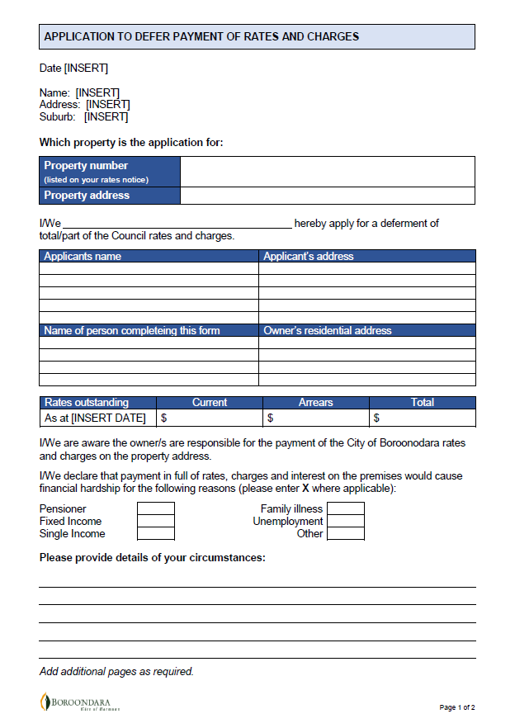
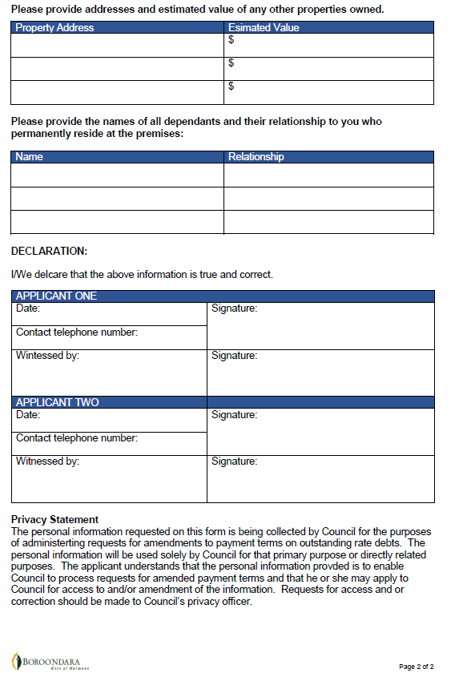

- Arrangement request form

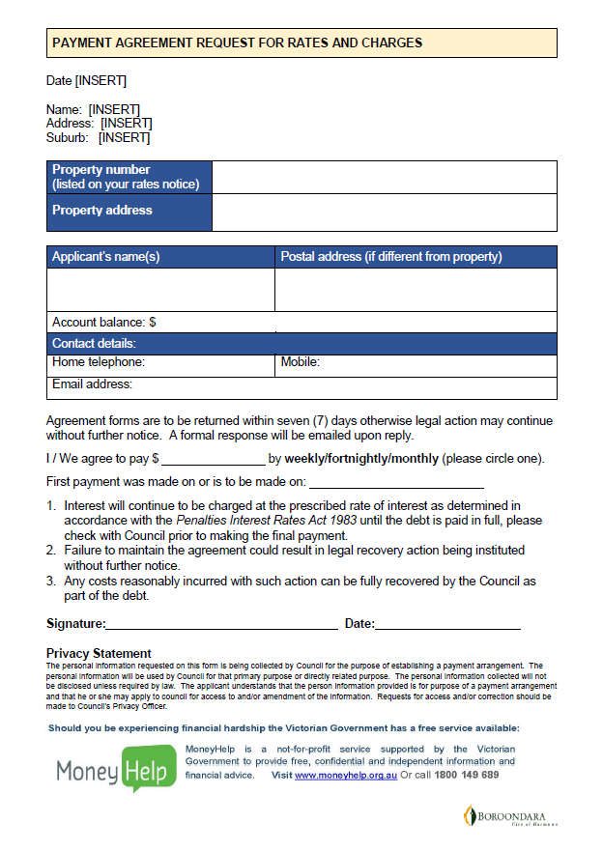
- Application for waiver of penalty interest on rates and charges

