Boroondara Planning Scheme

Batrouney House (former), 9 Seattle Street, Balwyn North
Statement of Significance, August 2022

Heritage Place: | Batrouney House (former)  9 Seattle Street, Balwyn North | PS ref no: | HO945

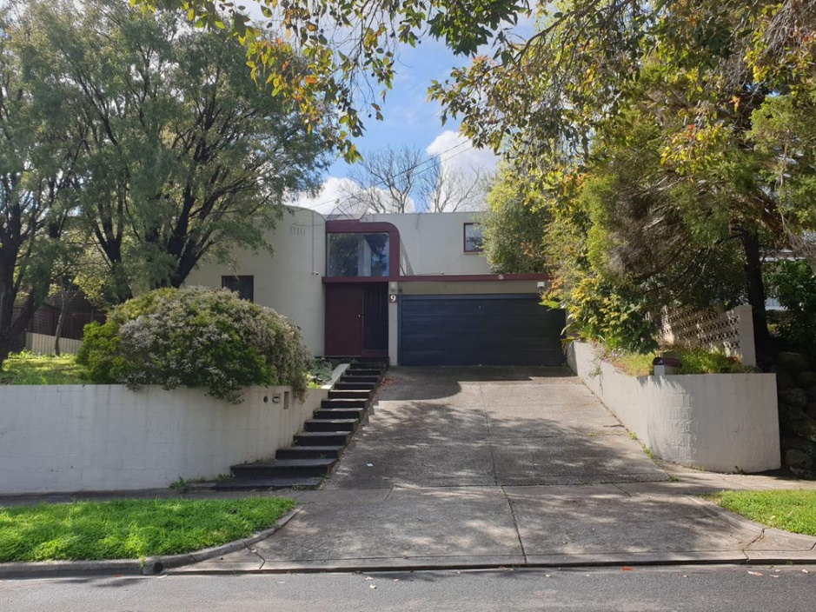

What is significant?
The former Batrouney House at 9 Seattle Street, Balwyn North, designed by architect Edgard Pirrotta in 1975, is significant.
Significant fabric includes asymmetrical built form with a steeply raked parapet wall and curved corner to the principal façade, walls of bagged concrete blocks, original external colour scheme (albeit subtly softened by the original owners), irregular roofline that incorporates sections that are variously flat, low-pitched or more steeply raked, all clad with metal tray deck roofing, a long glazed vault, made of curved timber beams with perspex infill, which extends all the way from the front door to the staircase in the rear wing, flat-roofed double carport, exposed chimney flues, rainwater heads and downpipes, flight of shallow concrete-paved steps that lead from the street to the front door, and bagged and painted concrete-block retaining wall with curved corner walls at the driveway entry. The garage door is a later addition and is not significant.
How is it significant?
The house is of historic and aesthetic significance to the City of Boroondara.
Why is it significant?
9 Seattle Street, Balwyn North, is of local historical significance for the evidence it provides of Boroondara as a locus for fine, leading architect-designed public and private buildings from the 1850s into the postwar period. Built in 1975 to a design by prominent Melbourne-based Italian architect Edgard Pirrotta of Morris & Pirrotta, 9 Seattle Street featured in architecture critic Norman Day’s 1976 publication Modern Houses: Melbourne, among profiles of some 50 modern houses by a then-emerging generation of younger architects. As a recipient of the September 1976 Age-RAIA House of the Week award, Batrouney House exemplifies the high concentration of modern mid-1970s houses in Boroondara that received architectural accolades or were awarded RAIA citations. (Criterion A)
9 Seattle Street, Balwyn North, is of local aesthetic significance as a fine and notably intact example of the Brutalist aesthetic as applied to residential architecture during the 1970s. With its irregular plan, jagged roofline and use of glazed vaulting, the house has a stark external form featuring walls of bagged concrete blocks and a roofline that incorporates sections that are variously flat, low-pitched or more steeply raked. The house retains many distinctive features including its long glazed vault, made of curved timber beams with perspex infill, which extends all the way from the front door to the staircase in the rear wing. As is typical of other examples of the style, the house’s chimney flues, rainwater heads and downpipes are all exposed. Being highly intact, and retaining its original front and side fences and entry steps, the house is a bold and eye-catching element in the streetscape. (Criterion E)

Primary source
Batrouney House (former), 9 Seattle Street, Balwyn North Heritage Citation (GML Heritage, July 2022)

This document is an incorporated document in the Boroondara Planning Scheme pursuant to section 6(2)(j) of the Planning and Environment Act 1987

